Assignment 1:

Vending machine

Object Oriented Programming using Java

Student Name: Martin Fennell

# Introduction

The aim of this project is to create a bending machine where a user can choose a product and buy it by inserting money much like a physical vending machine this is my first programming project.

The user is also able to clearly tell if the vending machine has stock of coins and products at any time they choose, they are also able to restock the machines coins and products if they choose to do so by logging into the restock form from the login form and the login form can be accessed via the main vending machine.

* Below are images of the main vending machine, login and restock GUI’s.

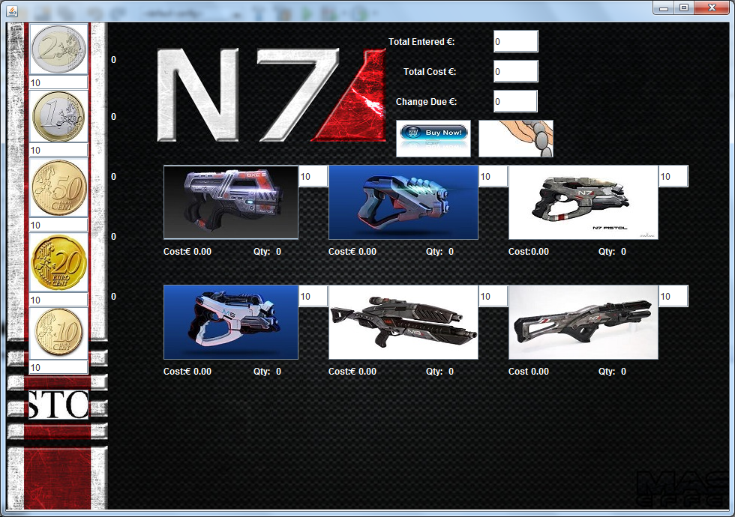

The image above is the N7vending Machine GUI.

In the N7Vending form you are able to choose up to as many as ten of each weapon and the cost of all the weapons chosen will be displayed in the total cost text field as well as each weapon will show their total individual cost under the weapons in the gun labels for the quantity chosen of that weapon. You can put in as much change as you wish into the machine and it will display how much you have entered in the total entered text field. You can then purchase the stock you have chosen but if you haven’t put enough change into the machine to purchase the selected products a message window will pop up telling you that you have not entered enough change. You are also able to cancel the chosen products you have selected if you press the cancel/refund button and if you have put any change into the machine it will refund the change and it will display the refunded change in the Change Due text field. When you run out of stock of any of the products a window will pop up telling you that you need to restock the product you can then press the restock button that will bring you to the login form.

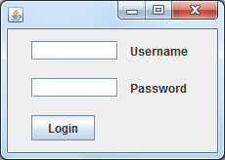

Above is an image of the Login GUI.

When In the Login form you have to input the username and password to progress onto the Restock Form but if you input the wrong username and/or password a window will pop up telling you that you entered the wrong username or password and if you enter the right details you will see a window that says login successful.

**Username: Martin**

**Password: nss2013**

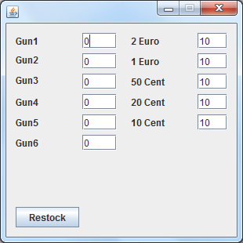

Above is an image of the Restock GUI.

When you are in the restock form you will see that the form displays the current stock of the machines coins and products and you have the ability to update the stock then when you press the restock button it will transfer the updated data back to the main vending machine and close the restock form window.

# Application Code

|  |  |
| --- | --- |
| Design Document |  |
| Public class N7Vending extends javax.swing.JFrame | This is the main class for the vending machine form where I declared my variables and my created methods that are used to pass information between the main form and the restock form.  E.g.: public static int WeaponStock1 = 0;  public static int EuroStock2 = 10;  public static int prevMoneyStock1= 0;  private int MethodForWeapon1(JTextField stock1) |
| private int MethodForWeapon1  private int MethodForWeapon2  private int MethodForTwoEuro(JTextField Euro2stock | These methods are the hand written methods I have created to link with the other methods in the main vending machine and restock form. They carry out an operation for the weapon1, weapon2 and 2Euro buttons. When any of the weapon buttons are pressed the weapon methods will then proceed to get the current stock of the chosen weapon and take the value of 1 away then it will send the new weapon value back to the link in the weapon button.  The method for the 2 Euro button is the same except that it adds the value of 1 to the current stock instead of taking it away from the stock.  E.g.: int NewStock1 = Integer.parseInt(stock1.getText());  NewStock1--;  stock1.setText("" + NewStock1);  return NewStock1; |
| private void weapon1ActionPerformed(java.awt.event.ActionEvent evt)  private void weapon1ActionPerformed(java.awt.event.ActionEvent evt)  private void weapon1ActionPerformed(java.awt.event.ActionEvent evt)  private void weapon1ActionPerformed(java.awt.event.ActionEvent evt)  private void weapon1ActionPerformed(java.awt.event.ActionEvent evt)  private void weapon1ActionPerformed(java.awt.event.ActionEvent evt) | These Methods are the ones created for the product buttons.  When any of the product buttons are pressed they carry out an operation to take the value of 1 away from the stock of the products and increase the quantity value of the chosen stock in their quantity labels by 1 as well as show the cost of the products in their individual cost labels and the total cost of all products chosen in the total cost text field.  The same operations are carried out for each of the 6 products and if the stock goes to 0 a message will pop up to tell you to restock them otherwise the other operations in the above paragraph will be carried out when each of the product buttons are pushed.  E.g.: double Weaponcost1 = (Double.parseDouble(gun1.getText()));  if (WeaponStock1 < 1.00) { JOptionPane.showMessageDialog(null, "Out of stock please restock");  stock1.setText("0.00"); }  else  WeaponStock1 = MethodForWeapon1(stock1);  stock1.setText("" + WeaponStock1); |
| private void euro2ActionPerformed(java.awt.event.ActionEvent evt)  private void euro1ActionPerformed(java.awt.event.ActionEvent evt)  private void cent50ActionPerformed(java.awt.event.ActionEvent evt)  private void cent20ActionPerformed(java.awt.event.ActionEvent evt)  private void cent10ActionPerformed(java.awt.event.ActionEvent evt) | These Methods are the ones created for the coin buttons.  When any of the coin buttons are pressed they carry out an operation to add the value of 1 to the stock of the coins and increase the quantity value of the chosen coins in their quantity labels by 1 as well as add the coins values to the total amount entered text field when each coin button is pressed.  The same operations are carried out for each of the 5 coins as well as when each of the coins are added to the total amount entered there is a decimal format code used to make sure there are only two digits after the decimal point.  E.g.: DecimalFormat df = new DecimalFormat("0.00");  CentStock50 = (Integer.parseInt(Cent50stock.getText()));  CentStock50 = CentStock50 + 1;  Cent50stock.setText("" + CentStock50);  double CentTotal50 = (Double.parseDouble(Totalentered.getText()));  CentTotal50 = CentTotal50 + 0.50;  Totalentered.setText("" + df.format(CentTotal50)); |
| private void formWindowOpened(java.awt.event.WindowEvent evt) | This is the method for the form window in the Main Vending Machine form it is linked to the form window in the Restock form which is where the stock and coin values are passed from to the Main machine to the restock form form.  E.g.: stock1.setText(String.valueOf(Frame1.GunToRestock1));  WeaponStock1 = Integer.parseInt(stock1.getText());  stock1.setText(WeaponStock1 + "");  RestockForm Frame1 = new RestockForm(); |
| private void restockActionPerformed(java.awt.event.ActionEvent evt) | This is the created method for the restock button when the button is pressed it closes the N7Vending window and opens the restock form.  E.g.: setVisible(false);  dispose();  Login Frame3 = new Login();  Frame3.setVisible(true); |
| private void buynowActionPerformed(java.awt.event.ActionEvent evt) | This method is applied to the buy now button in the vending machine. When the button is pressed it checks to see if there is enough change entered into the machine by the user and if there isn’t enough it carries out the start of an if else statement that displays a message window telling you that you haven’t entered enough change and if there is enough change it carries out the else operation which gives out the change owed to the user and takes the change variables from the coin stock in the machine and depending on the changed owed it will give out a 1 euro coin and a 20 cent coin if the change owed is €1.20. After the change has been given out it sets all the values of entered change quantity and chosen product quantity to zero so when the button is pressed again nothing happens.  The decimal format is also applied here so the number of zeros is two after the point in the change due textfield.  E.g.: double Total1 = (Double.parseDouble(Totalentered.getText()));  double Total2 = (Double.parseDouble(Totalcost.getText()));  double Ans2 = Total1 - Total2;  if (Total1 < Total2) {  JOptionPane.showMessageDialog(null, "Not enough change");  }  else  {  ChangeDue.setText("" + df.format(Ans2));  Totalentered.setText("0.00");  Totalcost.setText("0.00");  }  while (Ans1 > 0.00) {  else if (Ans1 >= 1.00) {  Ans1 = Ans1 - 1.00;  EuroStock1--;  Euro1stock.setText(EuroStock1 + "");  Euro1 = 0;  else if (Ans1 >= .20) {  Ans1 = Ans1 - 0.20;  CentStock20--;  Cent20stock.setText(CentStock20 + "");  Cent20 = 0; |
| private void refundActionPerformed(java.awt.event.ActionEvent evt) | This method applies to the Cancel/refund button when the cancel button is pressed if there is any change put into the machine by the user it will be refunded and if there are any products are put in as well they will be reset back to their original values.  If the cancel button is pressed after the buy now button has been used a message will pop up saying there is nothing to cancel because the values of the chosen products and coins put in were reset to zero after the button was used.  if (purchase == 0) {  JOptionPane.showMessageDialog(null, "Nothing to cancel");  } else {  DecimalFormat df = new DecimalFormat("0.00");  double ReturnRequest = (Double.parseDouble(Totalentered.getText()));  ChangeDue.setText("" + df.format(ReturnRequest));  if (Euro2 == 0) {  prevMoneyStock1 = EuroStock2;  } else {  prevMoneyStock1 = EuroStock2 - Euro2;  EuroStock2 = prevMoneyStock1;  Euro2stock.setText(prevMoneyStock1 + "");  show2.setText("0");  Euro2 = 0;  } |
|  |  |
| ***Stock*** |  |
| public class RestockForm extends javax.swing.JFrame | This method is the main class of the restock form it is where I declared the variables that are called from and too the main vending machine form.  E.g.: public static int GunToRestock1=10;  public static int CoinToRestock1=10; |
| private void formWindowOpened(java.awt.event.WindowEvent evt) | This is the method for the form window in the restock form it is linked to the form window in the main vending machine which is where the stock and coin values are passed from to the restock form.  E.g.: StockFrameGun1.setText(String.valueOf(frame2.WeaponStock1));  StockFrameCoin1.setText(String.valueOf(frame2.EuroStock2)); |
| private void RestockButtonActionPerformed(java.awt.event.ActionEvent evt) | This method is for the restock button in the restock form. When the restock form is opened the current values of stock and change in the N7 Vending form are passed via the form window methods and set in all of the text fields of the restock form the user can then change the stock and change as they see fit then push the restock button when this is done the new values are passed back to the N7 Form and then the restock window closes and opens up the main vending machine.  E.g.: GunToRestock1=Integer.parseInt(StockFrameGun1.getText());  StockFrameGun1.setText(GunToRestock1+"");  CoinToRestock1=Integer.parseInt(StockFrameCoin1.getText());  StockFrameCoin1.setText(CoinToRestock1+""); |
|  |  |
| ***LoginForm*** |  |
| public class Login extends javax.swing.JFrame | This is the method for the main class for the Login form. |
| private void jButton1ActionPerformed(java.awt.event.ActionEvent evt) | This is the method for the login button in the login form.  The user must enter the right password and username into the appropriate text fields then they can push the button if the details are correct the user will be logged into the restock form and a window will pop up saying login successful and will then close the login form but if the username or password is incorrect a window will pop up saying incorrect password or username.  E.g.: String username = (Username.getText());  String password = (Password.getText());  if (username.equals("Martin")&&password.equals("nss2013"))  {  JOptionPane.showMessageDialog(null,"Login successful");  RestockForm Frame1= new RestockForm();  Frame1.setVisible(true);  setVisible(false);  dispose();  }  else JOptionPane.showMessageDialog(null,"Incorrect Username or Password"); |

# Five Test Cases

# Test Case 1

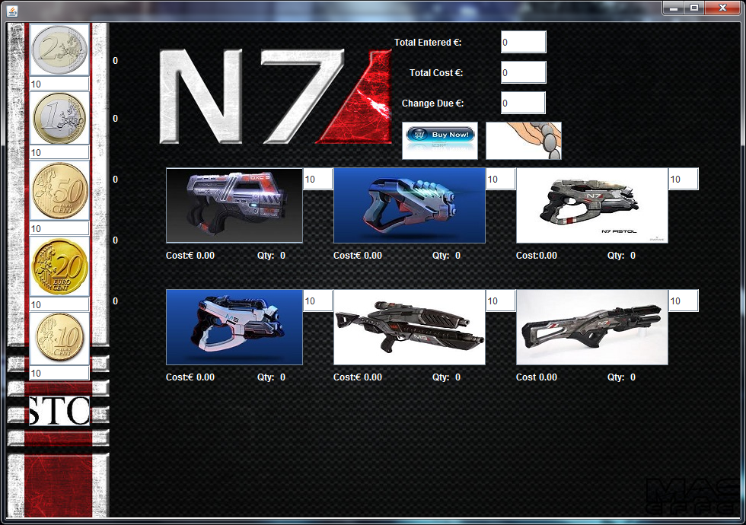

Above is a screen shot of the vending machine before any products or coins were selected.

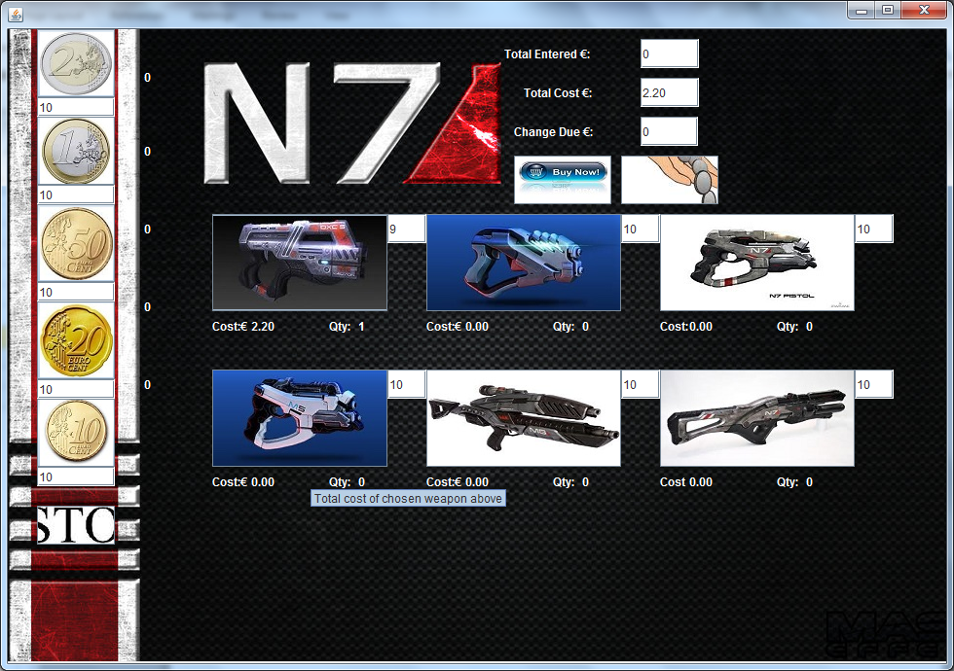

Above is a screen shot of the vending machine after weapon1 has been chosen.

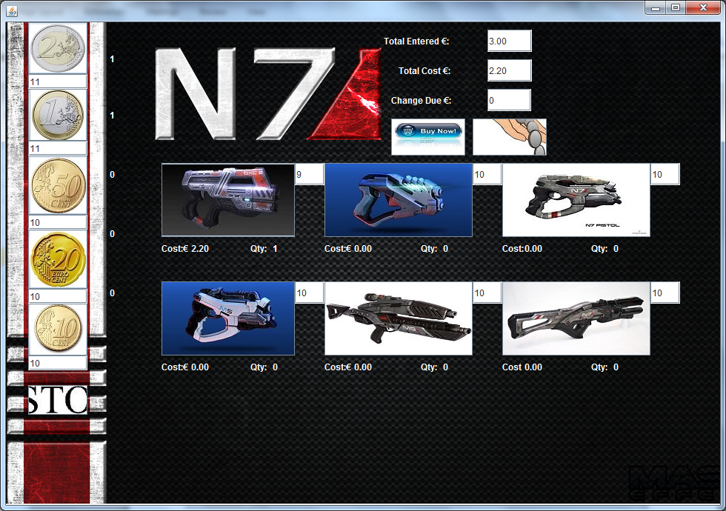

Above is a screen shot of the vending machine after the weapon1, 2 euro and 1 euro buttons have been selected.

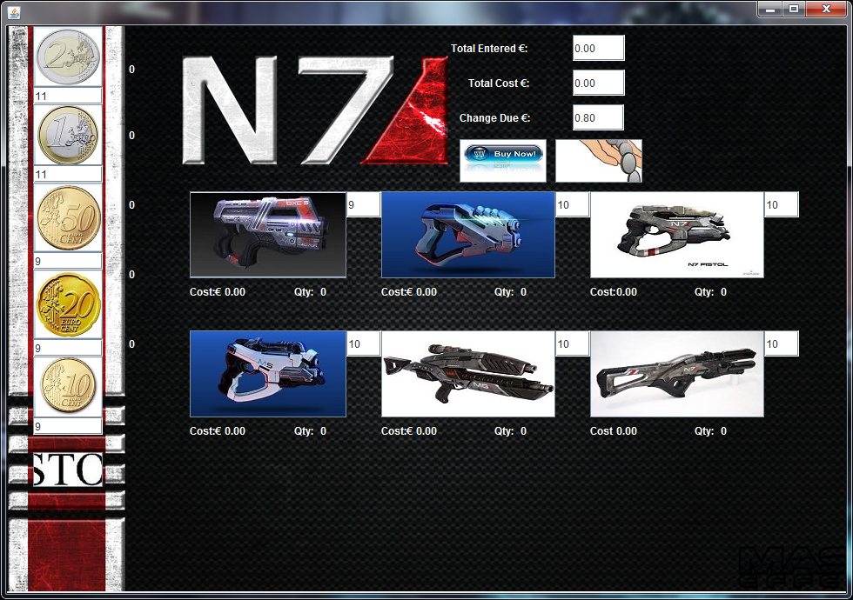

Above is a screenshot after weapon1 has been purchased and 80 cent change in 50, 20 and 10 cent coins have been given out.

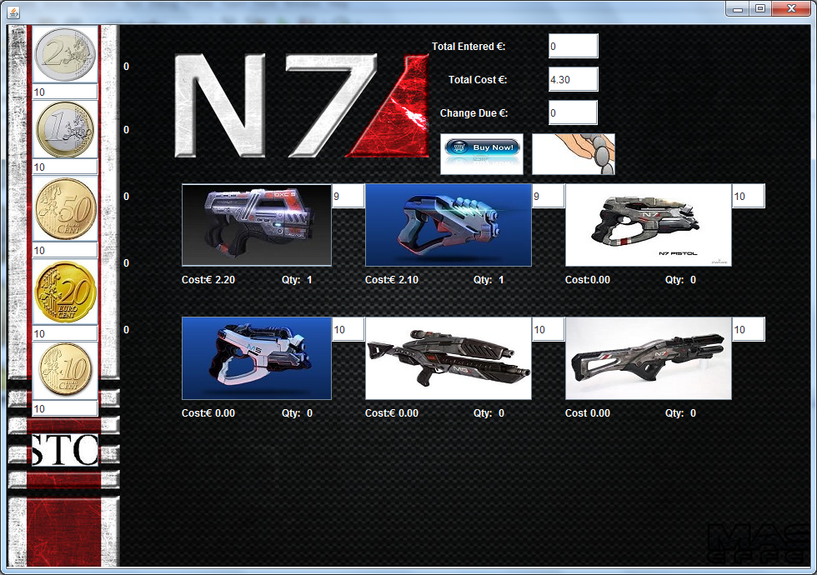

Above is a screenshot after weapons 1 and 2 have been selected.

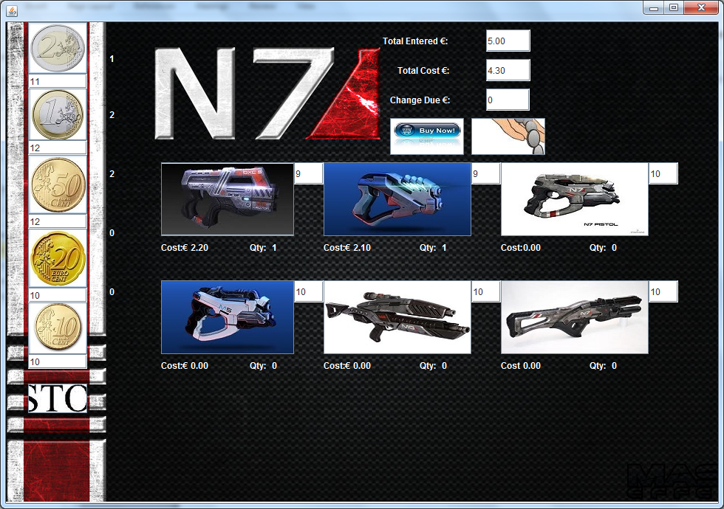

Above is a screenshot of weapons 1, 2 and 5 euro in 2 and 1 euro coins as well as 50 cent coins have been selected.

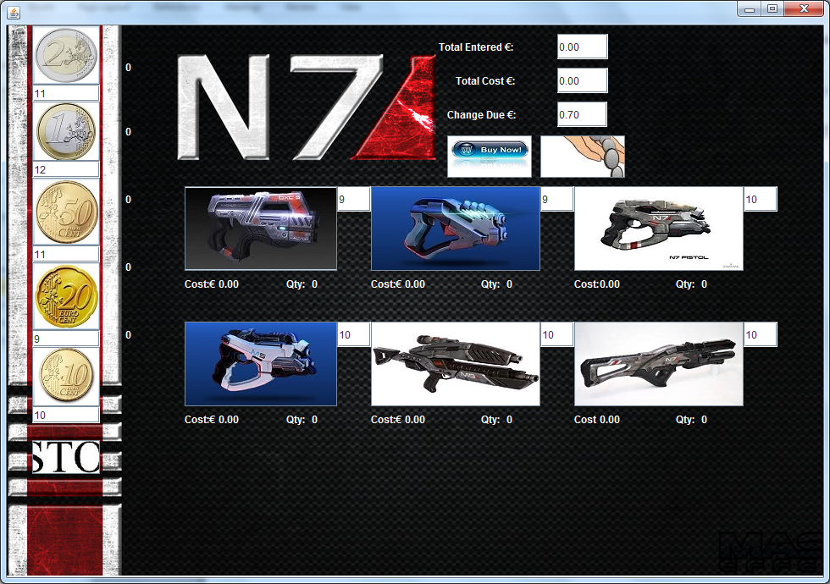

Above is a screenshot of 70 cent change been given out in 50 and 20 cent coins.

## Test Case 2

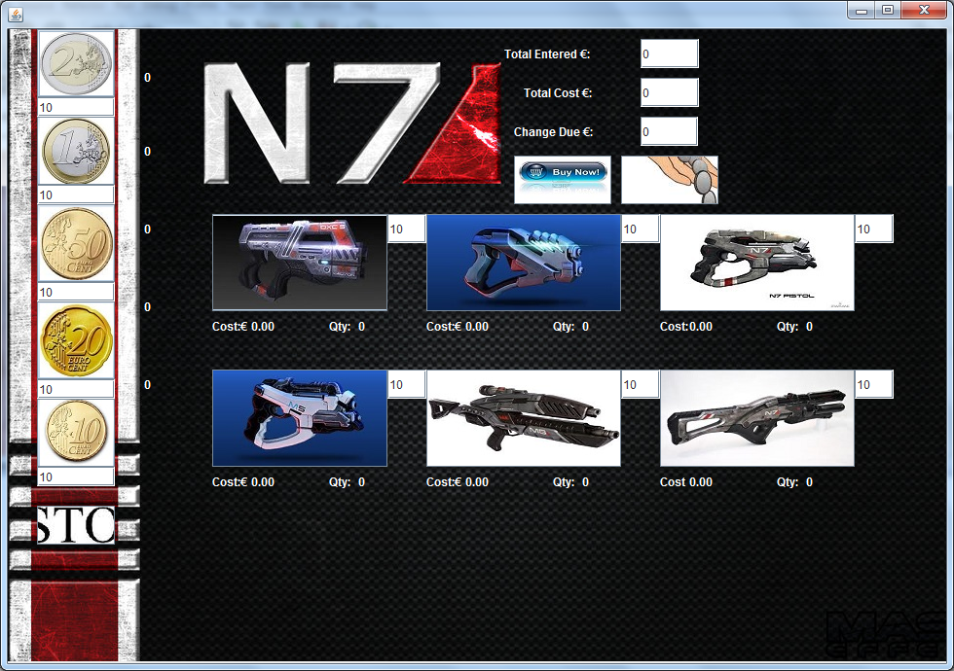

Above is a screenshot of the N7 form before anything has been selected.

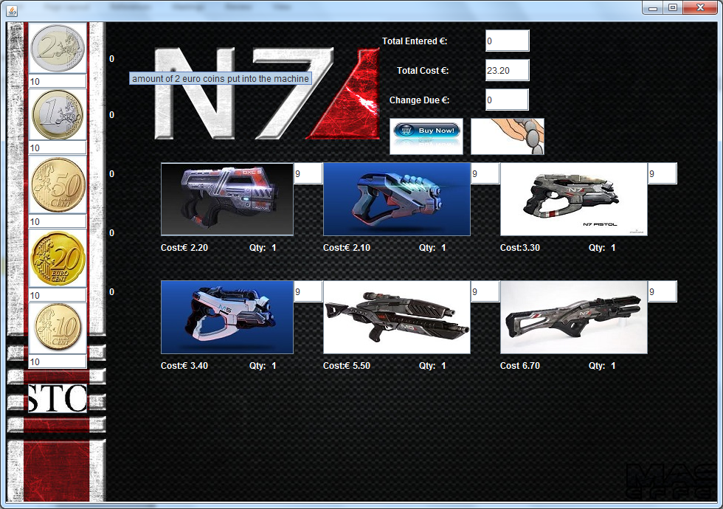

Above is one of each weapon selected.

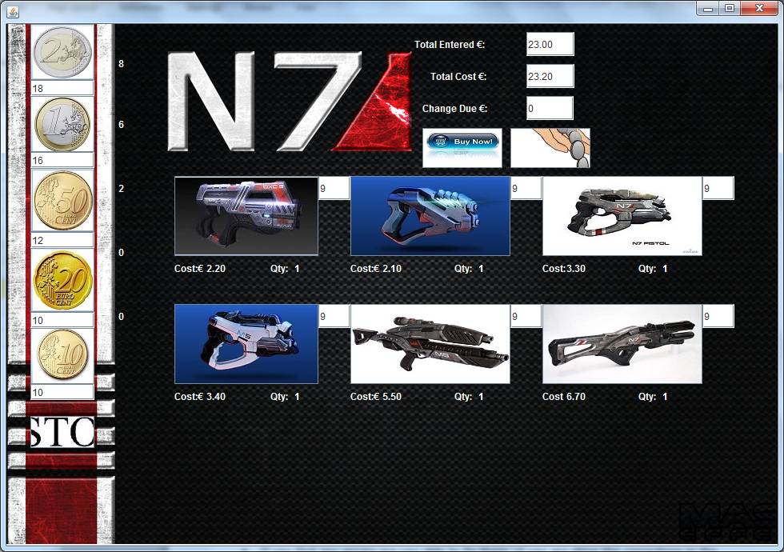

Above is a screenshot €23.20 worth of weapons selected and €23 worth of coins selected.

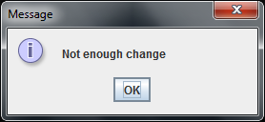

Above is a screenshot of the message window that popped up when I attempted purchase the purchase the weapons without putting enough change.

## Test Case 3

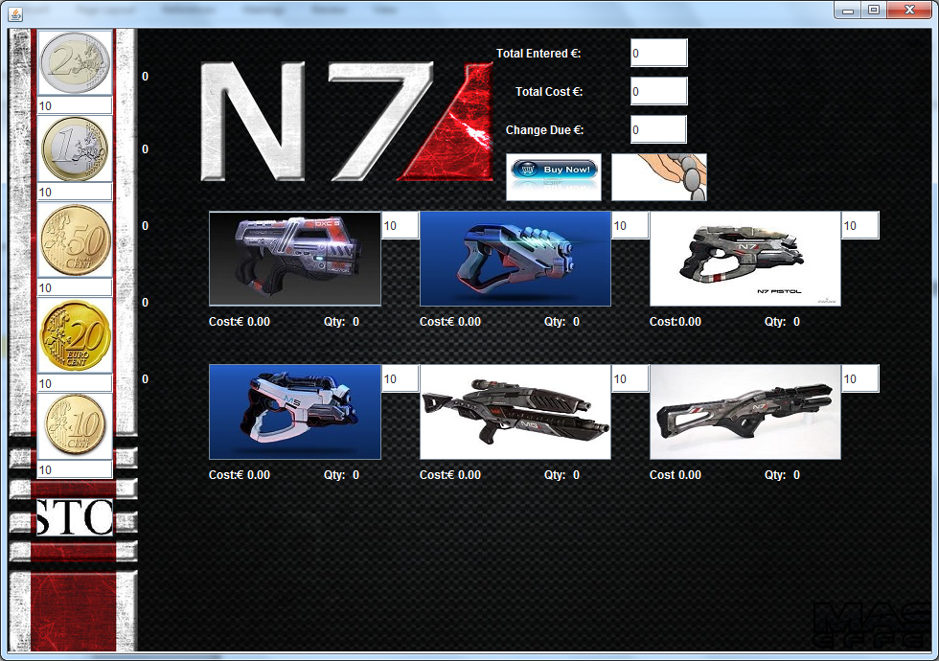

Above is a screenshot of the machine before I chose all of the weapon1 stock.

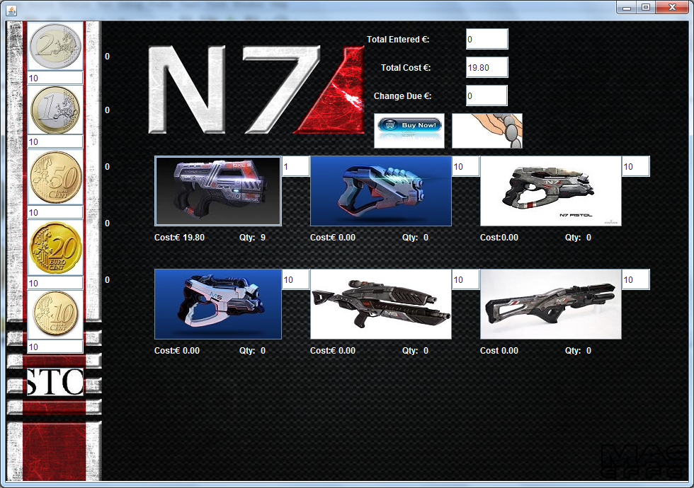

Above is a screen shot of nearly all the weapon 1 stock chosen.

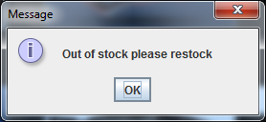

Above is a screenshot after I chose the entire weapon 1 stock and tried to choose it another time.

## Test Case 4

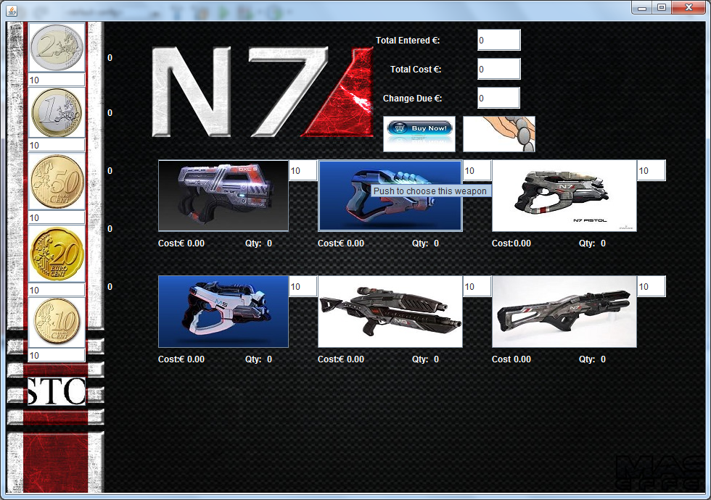

Above is a screenshot of the N7vending machine before I pressed the restock button

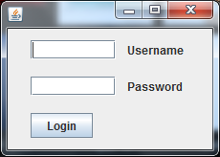

Above is a screenshot of the login screen

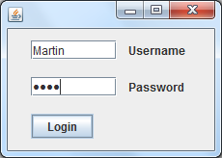

Above is a screenshot of the right user name but the wrong password in the login form.

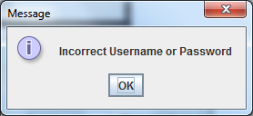

This is a screenshot after I entered the wrong password.

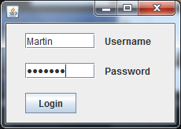

Above is a screenshot of the right password being typed in.

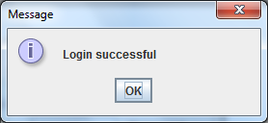

Above is a screenshot of a successful login after I entered the right username and password.

## Test Case 5

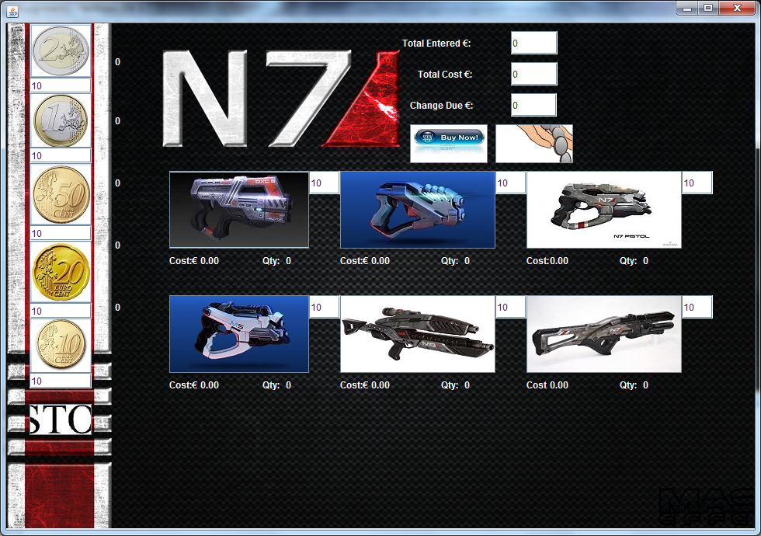

Above is a picture of the vending machine before I chose all of the weapon1 stock.

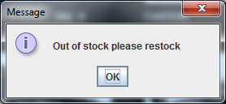

Above is a screenshot of a message window telling me I have to restock weapon 1.

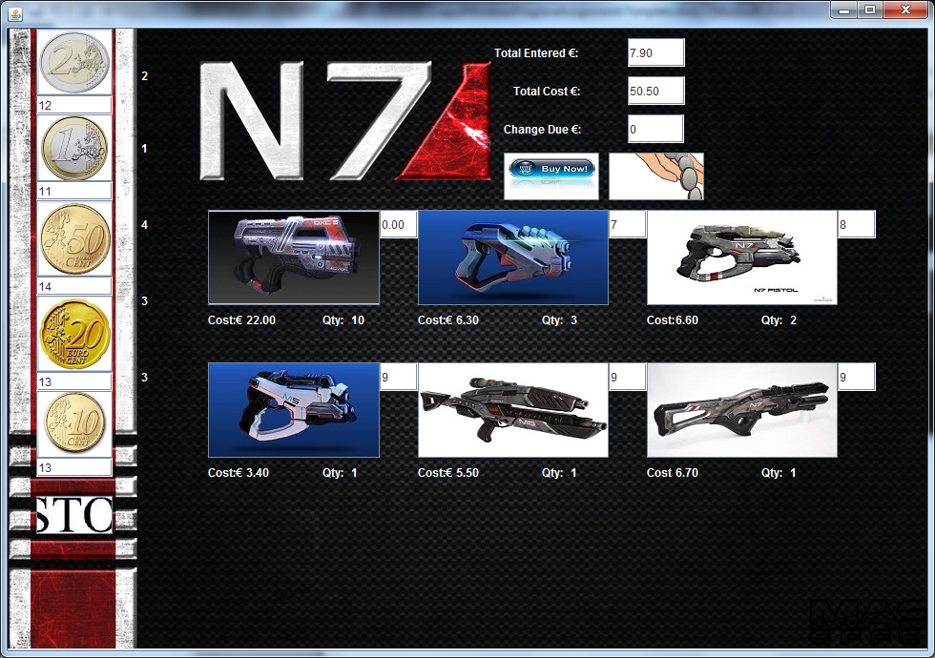

Above is a screenshot of current stock before I try to access the restock page.

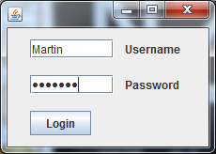

Above is a picture of me typing in the username and password into the login form.

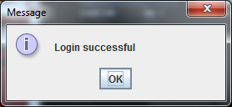

Above is a screenshot of a successful login.

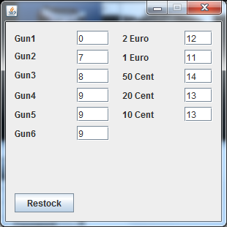

Above is a screenshot of the current stock in the vending machine as well as the coin stock that has been pulled into the restock form.

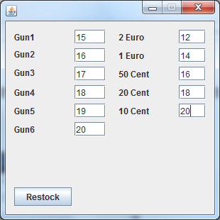

Above is a screenshot of the updated stock and coins in the restock form.

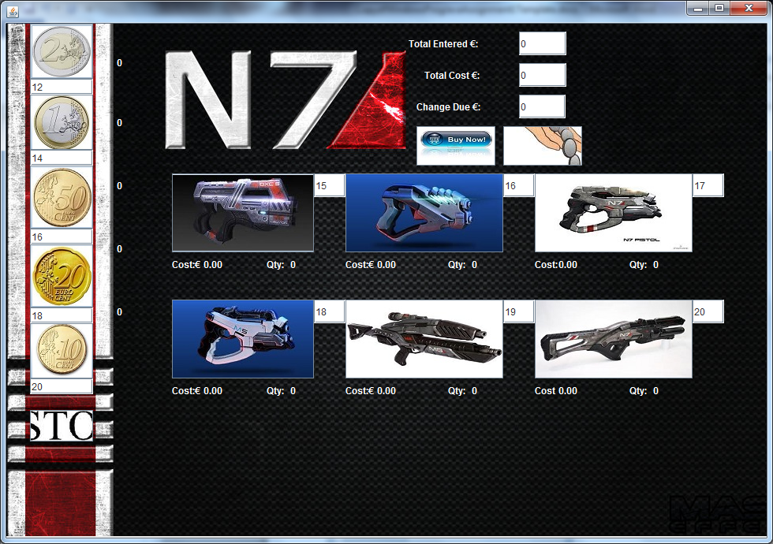

Above is a screenshot of the updated stock in the vending machine after I pressed the restock button.

Appendix 1 – Main Vending Machine:

import java.text.DecimalFormat;

import javax.swing.*;

/*

* To change this template, choose Tools | Templates

* and open the template in the editor.

*/

/*

* N7Vending.java

*

* Created on 08-Oct-2013, 15:23:58

*/

/**

*

* @author fennell.38261

*/

public class N7Vending extends javax.swing.JFrame {

public static int WeaponStock1 = 0;//this is a variable created to be used between classes on the main vending machine and the restock form.

public static int WeaponStock2 = 0;//this is a variable created to be used between classes on the main vending machine and the restock form.

public static int WeaponStock3 = 0;//this is a variable created to be used between classes on the main vending machine and the restock form.

public static int WeaponStock4 = 0;//this is a variable created to be used between classes on the main vending machine and the restock form.

public static int WeaponStock5 = 0;//this is a variable created to be used between classes on the main vending machine and the restock form.

public static int WeaponStock6 = 0;//this is a variable created to be used between classes on the main vending machine and the restock form.

public static int EuroStock2 = 10;//this is a variable created to be used between classes on the main vending machine and the restock form.

public static int EuroStock1 = 10;//this is a variable created to be used between classes on the main vending machine and the restock form.

public static int CentStock50 = 10;//this is a variable created to be used between classes on the main vending machine and the restock form.

public static int CentStock20 = 10;//this is a variable created to be used between classes on the main vending machine and the restock form.

public static int CentStock10 = 10;//this is a variable created to be used between classes on the main vending machine and the restock form.

public static int prevMoneyStock1 = 0;//this is a variable created to be used between classes on the main vending machine and the restock form.

public static int prevMoneyStock2 = 0;//this is a variable created to be used between classes on the main vending machine and the restock form.

public static int prevMoneyStock3 = 0;//this is a variable created to be used between classes on the main vending machine and the restock form.

public static int prevMoneyStock4 = 0;//this is a variable created to be used between classes on the main vending machine and the restock form.

public static int prevMoneyStock5 = 0;//this is a variable created to be used between classes on the main vending machine and the restock form.

public static int prevItemstock1 = 0;//this is a variable created to be used between classes on the main vending machine and the restock form.

public static int prevItemstock2 = 0;//this is a variable created to be used between classes on the main vending machine and the restock form.

public static int prevItemstock3 = 0;//this is a variable created to be used between classes on the main vending machine and the restock form.

public static int prevItemstock4 = 0;//this is a variable created to be used between classes on the main vending machine and the restock form.

public static int prevItemstock5 = 0;//this is a variable created to be used between classes on the main vending machine and the restock form.

public static int prevItemstock6 = 0;//this is a variable created to be used between classes on the main vending machine and the restock form.

public static int Itemstock1 = 0;//this is a variable created to be used between classes on the main vending machine form and the restock form.

public static int Itemstock2 = 0;//this is a variable created to be used between classes on the main vending machine and the restock form.

public static int Itemstock3 = 0;//this is a variable created to be used between classes on the main vending machine and the restock form.

public static int Itemstock4 = 0;//this is a variable created to be used between classes on the main vending machine and the restock form.

public static int Itemstock5 = 0;//this is a variable created to be used between classes on the main vending machine and the restock form.

public static int Itemstock6 = 0;//this is a variable created to be used between classes on the main vending machine and the restock form.

public static int Euro2 = 0;//this is a variable created to be used between classes on the main vending machine and the restock form.

public static int Euro1 = 0;//this is a variable created to be used between classes on the main vending machine and the restock form.

public static int Cent50 = 0;//this is a variable created to be used between classes on the main vending machine and the restock form.

public static int Cent20 = 0;//this is a variable created to be used between classes on the main vending machine and the restock form.

public static int Cent10 = 0;//this is a variable created to be used between classes on the main vending machine and the restock form.

public static int purchase = 1;//this is a variable created to be used between classes on the main vending machine and the restock form.

private int MethodForWeapon1(JTextField stock1)//this is the name of the method used to take in info about weapon1 in the vending machine.

{

int NewStock1 = Integer.parseInt(stock1.getText());//this line gets info on the current stock of weapon1 each time the weapon button is pressed.

NewStock1--;//this line takes the value of 1 from the stock of weapon 1 each time the button is pressed.

stock1.setText("" + NewStock1);//this line sets the info to NewStock1 after the above code has carried out its operations out.

return NewStock1;//this line of code returns all info to the method link in the weapon 1 button.

}

private int MethodForWeapon2(JTextField stock2) {//this is the name of the method used to take in info about weapon 2 in the vending machine.

int NewStock2 = Integer.parseInt(stock2.getText());//this line gets info on the current stock of weapon2 each time the weapon button is pressed.

NewStock2--;//this line takes the value of 1 from the stock of weapon 2 each time the button is pressed.

stock2.setText("" + NewStock2);//this line sets the info to NewStock2 after the above code has carried out its operations out.

return NewStock2;//this line of code returns all info to the method link in the weapon 2 button.

}

private int MethodForTwoEuro(JTextField Euro2stock) {//this is the name of the method used to take in info about The two euro button in the vending machine.

int NewCoinStock2 = Integer.parseInt(Euro2stock.getText());//this line gets info on the current stock of the 2 Euro button each time button is pressed.

NewCoinStock2++;//this line adds the value of 1 from the stock of EuroStock2 each time the button is pressed.

Euro2stock.setText("" + NewCoinStock2);//this line sets the info to NewcoinStock2 after the above code has carried out its operations out.

return NewCoinStock2;//this line of code returns all info to the method link in the Euro 2 button.

}

/**

* Creates new form N7Vending

*/

public N7Vending() {

initComponents();

}

/**

* This method is called from within the constructor to initialize the form.

* WARNING: Do NOT modify this code. The content of this method is always

* regenerated by the Form Editor.

*/

@SuppressWarnings("unchecked")

// <editor-fold defaultstate="collapsed" desc="Generated Code">

private void initComponents() {

weapon1 = new javax.swing.JButton();

weapon2 = new javax.swing.JButton();

weapon3 = new javax.swing.JButton();

weapon4 = new javax.swing.JButton();

weapon5 = new javax.swing.JButton();

weapon6 = new javax.swing.JButton();

euro2 = new javax.swing.JButton();

euro1 = new javax.swing.JButton();

cent50 = new javax.swing.JButton();

cent20 = new javax.swing.JButton();

cent10 = new javax.swing.JButton();

gun1 = new javax.swing.JLabel();

costlabel1 = new javax.swing.JLabel();

jLabel3 = new javax.swing.JLabel();

jLabel4 = new javax.swing.JLabel();

jLabel5 = new javax.swing.JLabel();

jLabel6 = new javax.swing.JLabel();

jLabel7 = new javax.swing.JLabel();

show2 = new javax.swing.JLabel();

show1 = new javax.swing.JLabel();

show50 = new javax.swing.JLabel();

show20 = new javax.swing.JLabel();

show10 = new javax.swing.JLabel();

restock = new javax.swing.JButton();

refund = new javax.swing.JButton();

buynow = new javax.swing.JButton();

gun2 = new javax.swing.JLabel();

gun3 = new javax.swing.JLabel();

gun4 = new javax.swing.JLabel();

gun6 = new javax.swing.JLabel();

gun5 = new javax.swing.JLabel();

stock1 = new javax.swing.JTextField();

Totalcost = new javax.swing.JTextField();

stock2 = new javax.swing.JTextField();

stock3 = new javax.swing.JTextField();

stock4 = new javax.swing.JTextField();

stock5 = new javax.swing.JTextField();

stock6 = new javax.swing.JTextField();

Totalentered = new javax.swing.JTextField();

Qty2 = new javax.swing.JLabel();

jLabel2 = new javax.swing.JLabel();

Qty1 = new javax.swing.JLabel();

jLabel1 = new javax.swing.JLabel();

jLabel8 = new javax.swing.JLabel();

Qty3 = new javax.swing.JLabel();

jLabel9 = new javax.swing.JLabel();

Qty4 = new javax.swing.JLabel();

jLabel10 = new javax.swing.JLabel();

Qty5 = new javax.swing.JLabel();

jLabel12 = new javax.swing.JLabel();

Qty6 = new javax.swing.JLabel();

jLabel13 = new javax.swing.JLabel();

jLabel11 = new javax.swing.JLabel();

jLabel14 = new javax.swing.JLabel();

ChangeDue = new javax.swing.JTextField();

Euro2stock = new javax.swing.JTextField();

Euro1stock = new javax.swing.JTextField();

Cent50stock = new javax.swing.JTextField();

Cent20stock = new javax.swing.JTextField();

Cent10stock = new javax.swing.JTextField();

Background = new javax.swing.JLabel();

setDefaultCloseOperation(javax.swing.WindowConstants.EXIT_ON_CLOSE);

setMinimumSize(new java.awt.Dimension(980, 690));

addWindowListener(new java.awt.event.WindowAdapter() {

public void windowOpened(java.awt.event.WindowEvent evt) {

formWindowOpened(evt);

}

});

getContentPane().setLayout(null);

weapon1.setIcon(new javax.swing.ImageIcon(getClass().getResource("/weapon 1.jpg"))); // NOI18N

weapon1.setToolTipText("Push to choose this weapon ");

weapon1.addActionListener(new java.awt.event.ActionListener() {

public void actionPerformed(java.awt.event.ActionEvent evt) {

weapon1ActionPerformed(evt);

}

});

getContentPane().add(weapon1);

weapon1.setBounds(210, 190, 180, 100);

weapon2.setIcon(new javax.swing.ImageIcon(getClass().getResource("/weapon 2.jpg"))); // NOI18N

weapon2.setToolTipText("Push to choose this weapon ");

weapon2.addActionListener(new java.awt.event.ActionListener() {

public void actionPerformed(java.awt.event.ActionEvent evt) {

weapon2ActionPerformed(evt);

}

});

getContentPane().add(weapon2);

weapon2.setBounds(430, 190, 200, 100);

weapon3.setIcon(new javax.swing.ImageIcon(getClass().getResource("/weapon 3.jpg"))); // NOI18N

weapon3.setToolTipText("Push to choose this weapon ");

weapon3.addActionListener(new java.awt.event.ActionListener() {

public void actionPerformed(java.awt.event.ActionEvent evt) {

weapon3ActionPerformed(evt);

}

});

getContentPane().add(weapon3);

weapon3.setBounds(670, 190, 200, 100);

weapon4.setIcon(new javax.swing.ImageIcon(getClass().getResource("/weapon 4.jpg"))); // NOI18N

weapon4.setToolTipText("Push to choose this weapon ");

weapon4.addActionListener(new java.awt.event.ActionListener() {

public void actionPerformed(java.awt.event.ActionEvent evt) {

weapon4ActionPerformed(evt);

}

});

getContentPane().add(weapon4);

weapon4.setBounds(210, 350, 180, 100);

weapon5.setIcon(new javax.swing.ImageIcon(getClass().getResource("/weapon 6.jpg"))); // NOI18N

weapon5.setToolTipText("Push to choose this weapon ");

weapon5.addActionListener(new java.awt.event.ActionListener() {

public void actionPerformed(java.awt.event.ActionEvent evt) {

weapon5ActionPerformed(evt);

}

});

getContentPane().add(weapon5);

weapon5.setBounds(430, 350, 200, 100);

weapon6.setIcon(new javax.swing.ImageIcon(getClass().getResource("/weapons 7.jpg"))); // NOI18N

weapon6.setToolTipText("Push to choose this weapon ");

weapon6.addActionListener(new java.awt.event.ActionListener() {

public void actionPerformed(java.awt.event.ActionEvent evt) {

weapon6ActionPerformed(evt);

}

});

getContentPane().add(weapon6);

weapon6.setBounds(670, 350, 200, 100);

euro2.setIcon(new javax.swing.ImageIcon(getClass().getResource("/2 euro.jpg"))); // NOI18N

euro2.setToolTipText("Push to put a 2 euro coin into the machine");

euro2.setMaximumSize(new java.awt.Dimension(261, 231));

euro2.setMinimumSize(new java.awt.Dimension(260, 230));

euro2.setPreferredSize(new java.awt.Dimension(260, 230));

euro2.addActionListener(new java.awt.event.ActionListener() {

public void actionPerformed(java.awt.event.ActionEvent evt) {

euro2ActionPerformed(evt);

}

});

getContentPane().add(euro2);

euro2.setBounds(30, 10, 80, 70);

euro1.setIcon(new javax.swing.ImageIcon(getClass().getResource("/1 euro coin.jpg"))); // NOI18N

euro1.setToolTipText("Push to put a 1 euro coin into the machine");

euro1.addActionListener(new java.awt.event.ActionListener() {

public void actionPerformed(java.awt.event.ActionEvent evt) {

euro1ActionPerformed(evt);

}

});

getContentPane().add(euro1);

euro1.setBounds(30, 120, 80, 70);

cent50.setIcon(new javax.swing.ImageIcon(getClass().getResource("/50 cent coin.jpg"))); // NOI18N

cent50.setToolTipText("Push to put a 50 cent coin into the machine");

cent50.addActionListener(new java.awt.event.ActionListener() {

public void actionPerformed(java.awt.event.ActionEvent evt) {

cent50ActionPerformed(evt);

}

});

getContentPane().add(cent50);

cent50.setBounds(30, 230, 80, 80);

cent20.setIcon(new javax.swing.ImageIcon(getClass().getResource("/20 cent coin.jpg"))); // NOI18N

cent20.setToolTipText("Push to put a 20 cent coin into the machine");

cent20.addActionListener(new java.awt.event.ActionListener() {

public void actionPerformed(java.awt.event.ActionEvent evt) {

cent20ActionPerformed(evt);

}

});

getContentPane().add(cent20);

cent20.setBounds(30, 350, 80, 80);

cent10.setIcon(new javax.swing.ImageIcon(getClass().getResource("/10 cent coin.jpg"))); // NOI18N

cent10.setToolTipText("Push to put a 10 cent coin into the machine");

cent10.addActionListener(new java.awt.event.ActionListener() {

public void actionPerformed(java.awt.event.ActionEvent evt) {

cent10ActionPerformed(evt);

}

});

getContentPane().add(cent10);

cent10.setBounds(30, 470, 80, 70);

gun1.setForeground(new java.awt.Color(255, 255, 255));

gun1.setText("0.00");

gun1.setToolTipText("Total cost of chosen weapon above");

getContentPane().add(gun1);

gun1.setBounds(250, 290, 80, 30);

costlabel1.setBackground(new java.awt.Color(255, 255, 255));

costlabel1.setForeground(new java.awt.Color(255, 255, 255));

costlabel1.setText("Cost:€");

costlabel1.setToolTipText("Cost lable for individual weapon cost");

getContentPane().add(costlabel1);

costlabel1.setBounds(210, 290, 40, 30);

jLabel3.setForeground(new java.awt.Color(255, 255, 255));

jLabel3.setText("Cost:€");

jLabel3.setToolTipText("Cost lable for individual weapon cost");

getContentPane().add(jLabel3);

jLabel3.setBounds(430, 290, 40, 30);

jLabel4.setForeground(new java.awt.Color(255, 255, 255));

jLabel4.setText("Cost:");

jLabel4.setToolTipText("Cost lable for individual weapon cost");

getContentPane().add(jLabel4);

jLabel4.setBounds(670, 290, 30, 30);

jLabel5.setForeground(new java.awt.Color(255, 255, 255));

jLabel5.setText("Cost:€");

jLabel5.setToolTipText("Cost lable for individual weapon cost");

getContentPane().add(jLabel5);

jLabel5.setBounds(210, 450, 40, 30);

jLabel6.setForeground(new java.awt.Color(255, 255, 255));

jLabel6.setText("Cost:€");

jLabel6.setToolTipText("Cost lable for individual weapon cost");

getContentPane().add(jLabel6);

jLabel6.setBounds(430, 450, 40, 30);

jLabel7.setForeground(new java.awt.Color(255, 255, 255));

jLabel7.setText("Cost");

jLabel7.setToolTipText("Cost lable for individual weapon cost");

getContentPane().add(jLabel7);

jLabel7.setBounds(670, 450, 30, 30);

show2.setBackground(new java.awt.Color(255, 255, 255));

show2.setForeground(new java.awt.Color(255, 255, 255));

show2.setText("0");

show2.setToolTipText("amount of 2 euro coins put into the machine");

getContentPane().add(show2);

show2.setBounds(140, 14, 40, 70);

show1.setForeground(new java.awt.Color(255, 255, 255));

show1.setText("0");

show1.setToolTipText("amount of 2 euro coins put into the machine");

getContentPane().add(show1);

show1.setBounds(140, 90, 40, 70);

show50.setForeground(new java.awt.Color(255, 255, 255));

show50.setText("0");

show50.setToolTipText("amount of 50 cent coins put into the machine");

getContentPane().add(show50);

show50.setBounds(140, 170, 40, 70);

show20.setForeground(new java.awt.Color(255, 255, 255));

show20.setText("0");

show20.setToolTipText("amount of 20 cent coins put into the machine");

getContentPane().add(show20);

show20.setBounds(140, 250, 40, 70);

show10.setForeground(new java.awt.Color(255, 255, 255));

show10.setText("0");

show10.setToolTipText("amount of 10 cent coins put into the machine");

getContentPane().add(show10);

show10.setBounds(140, 330, 40, 70);

restock.setIcon(new javax.swing.ImageIcon(getClass().getResource("/Re-stock.jpg"))); // NOI18N

restock.setToolTipText("Restock button");

restock.addActionListener(new java.awt.event.ActionListener() {

public void actionPerformed(java.awt.event.ActionEvent evt) {

restockActionPerformed(evt);

}

});

getContentPane().add(restock);

restock.setBounds(30, 580, 80, 40);

refund.setIcon(new javax.swing.ImageIcon(getClass().getResource("/Refund.jpg"))); // NOI18N

refund.setToolTipText("Refund/Cancel button");

refund.addActionListener(new java.awt.event.ActionListener() {

public void actionPerformed(java.awt.event.ActionEvent evt) {

refundActionPerformed(evt);

}

});

getContentPane().add(refund);

refund.setBounds(630, 130, 100, 50);

buynow.setIcon(new javax.swing.ImageIcon(getClass().getResource("/Purchase.jpg"))); // NOI18N

buynow.setToolTipText("Purchase button");

buynow.addActionListener(new java.awt.event.ActionListener() {

public void actionPerformed(java.awt.event.ActionEvent evt) {

buynowActionPerformed(evt);

}

});

getContentPane().add(buynow);

buynow.setBounds(520, 130, 100, 50);

gun2.setForeground(new java.awt.Color(255, 255, 255));

gun2.setText("0.00");

gun2.setToolTipText("Total cost of chosen weapon above");

getContentPane().add(gun2);

gun2.setBounds(470, 290, 90, 30);

gun3.setForeground(new java.awt.Color(255, 255, 255));

gun3.setText("0.00");

gun3.setToolTipText("Total cost of chosen weapon above");

getContentPane().add(gun3);

gun3.setBounds(700, 290, 90, 30);

gun4.setForeground(new java.awt.Color(255, 255, 255));

gun4.setText("0.00");

gun4.setToolTipText("Total cost of chosen weapon above");

getContentPane().add(gun4);

gun4.setBounds(250, 450, 80, 30);

gun6.setForeground(new java.awt.Color(255, 255, 255));

gun6.setText("0.00");

gun6.setToolTipText("Total cost of chosen weapon above");

getContentPane().add(gun6);

gun6.setBounds(700, 450, 90, 30);

gun5.setForeground(new java.awt.Color(255, 255, 255));

gun5.setText("0.00");

gun5.setToolTipText("Total cost of chosen weapon above");

getContentPane().add(gun5);

gun5.setBounds(470, 450, 90, 30);

stock1.setText("10");

stock1.setToolTipText("Stock of the weapon to the left");

stock1.addActionListener(new java.awt.event.ActionListener() {

public void actionPerformed(java.awt.event.ActionEvent evt) {

stock1ActionPerformed(evt);

}

});

getContentPane().add(stock1);

stock1.setBounds(390, 190, 40, 30);

Totalcost.setText("0");

Totalcost.setToolTipText("Total cost of all weapons");

Totalcost.addActionListener(new java.awt.event.ActionListener() {

public void actionPerformed(java.awt.event.ActionEvent evt) {

TotalcostActionPerformed(evt);

}

});

getContentPane().add(Totalcost);

Totalcost.setBounds(650, 50, 60, 30);

stock2.setText("10");

stock2.setToolTipText("Stock of the weapon to the left");

getContentPane().add(stock2);

stock2.setBounds(630, 190, 40, 30);

stock3.setText("10");

stock3.setToolTipText("Stock of the weapon to the left");

stock3.addActionListener(new java.awt.event.ActionListener() {

public void actionPerformed(java.awt.event.ActionEvent evt) {

stock3ActionPerformed(evt);

}

});

getContentPane().add(stock3);

stock3.setBounds(870, 190, 40, 30);

stock4.setText("10");

stock4.setToolTipText("Stock of the weapon to the left");

getContentPane().add(stock4);

stock4.setBounds(390, 350, 40, 30);

stock5.setText("10");

stock5.setToolTipText("Stock of the weapon to the left");

getContentPane().add(stock5);

stock5.setBounds(630, 350, 40, 30);

stock6.setText("10");

stock6.setToolTipText("Stock of the weapon to the left");

getContentPane().add(stock6);

stock6.setBounds(870, 350, 40, 30);

Totalentered.setText("0");

Totalentered.setToolTipText("Coins Entered into the machine");

Totalentered.addActionListener(new java.awt.event.ActionListener() {

public void actionPerformed(java.awt.event.ActionEvent evt) {

TotalenteredActionPerformed(evt);

}

});

getContentPane().add(Totalentered);

Totalentered.setBounds(650, 10, 60, 30);

Qty2.setForeground(new java.awt.Color(255, 255, 255));

Qty2.setText("0");

Qty2.setToolTipText("Quantity chosen of weapon above");

getContentPane().add(Qty2);

Qty2.setBounds(590, 290, 40, 30);

jLabel2.setForeground(new java.awt.Color(255, 255, 255));

jLabel2.setText("Qty:");

jLabel2.setToolTipText("Quantity Lable");

getContentPane().add(jLabel2);

jLabel2.setBounds(330, 290, 30, 30);

Qty1.setForeground(new java.awt.Color(255, 255, 255));

Qty1.setText("0");

Qty1.setToolTipText("Quantity chosen of weapon above");

getContentPane().add(Qty1);

Qty1.setBounds(360, 290, 30, 30);

jLabel1.setForeground(new java.awt.Color(255, 255, 255));

jLabel1.setText("Qty:");

jLabel1.setToolTipText("Quantity Lable");

getContentPane().add(jLabel1);

jLabel1.setBounds(560, 290, 30, 30);

jLabel8.setForeground(new java.awt.Color(255, 255, 255));

jLabel8.setText("Qty:");

jLabel8.setToolTipText("Quantity Lable");

getContentPane().add(jLabel8);

jLabel8.setBounds(790, 290, 30, 30);

Qty3.setForeground(new java.awt.Color(255, 255, 255));

Qty3.setText("0");

Qty3.setToolTipText("Quantity chosen of weapon above");

getContentPane().add(Qty3);

Qty3.setBounds(820, 290, 50, 30);

jLabel9.setForeground(new java.awt.Color(255, 255, 255));

jLabel9.setText("Qty:");

jLabel9.setToolTipText("Quantity Lable");

getContentPane().add(jLabel9);

jLabel9.setBounds(330, 450, 30, 30);

Qty4.setForeground(new java.awt.Color(255, 255, 255));

Qty4.setText("0");

Qty4.setToolTipText("Quantity chosen of weapon above");

getContentPane().add(Qty4);

Qty4.setBounds(360, 450, 30, 30);

jLabel10.setForeground(new java.awt.Color(255, 255, 255));

jLabel10.setText("Qty:");

jLabel10.setToolTipText("Quantity Lable");

getContentPane().add(jLabel10);

jLabel10.setBounds(560, 450, 30, 30);

Qty5.setForeground(new java.awt.Color(255, 255, 255));

Qty5.setText("0");

Qty5.setToolTipText("Quantity chosen of weapon above");

getContentPane().add(Qty5);

Qty5.setBounds(590, 450, 40, 30);

jLabel12.setForeground(new java.awt.Color(255, 255, 255));

jLabel12.setText("Qty:");

jLabel12.setToolTipText("Quantity Lable");

getContentPane().add(jLabel12);

jLabel12.setBounds(790, 450, 30, 30);

Qty6.setForeground(new java.awt.Color(255, 255, 255));

Qty6.setText("0");

Qty6.setToolTipText("Quantity chosen of weapon above");

getContentPane().add(Qty6);

Qty6.setBounds(820, 450, 50, 30);

jLabel13.setForeground(new java.awt.Color(255, 255, 255));

jLabel13.setText("Total Cost €:");

getContentPane().add(jLabel13);

jLabel13.setBounds(530, 50, 110, 30);

jLabel11.setForeground(new java.awt.Color(255, 255, 255));

jLabel11.setText("Total Entered €:");

getContentPane().add(jLabel11);

jLabel11.setBounds(510, 10, 130, 30);

jLabel14.setForeground(new java.awt.Color(255, 255, 255));

jLabel14.setText("Change Due €:");

getContentPane().add(jLabel14);

jLabel14.setBounds(520, 90, 120, 30);

ChangeDue.setText("0");

ChangeDue.setToolTipText("Change due after refund or purchase buttons hit");

getContentPane().add(ChangeDue);

ChangeDue.setBounds(650, 90, 59, 30);

Euro2stock.setText("10");

Euro2stock.setToolTipText("Stock of the coin above");

Euro2stock.addActionListener(new java.awt.event.ActionListener() {

public void actionPerformed(java.awt.event.ActionEvent evt) {

Euro2stockActionPerformed(evt);

}

});

getContentPane().add(Euro2stock);

Euro2stock.setBounds(30, 80, 80, 26);

Euro1stock.setText("10");

Euro1stock.setToolTipText("Stock of the coin above");

getContentPane().add(Euro1stock);

Euro1stock.setBounds(30, 190, 80, 26);

Cent50stock.setText("10");

Cent50stock.setToolTipText("Stock of the coin above");

getContentPane().add(Cent50stock);

Cent50stock.setBounds(30, 310, 80, 26);

Cent20stock.setText("10");

Cent20stock.setToolTipText("Stock of the coin above");

getContentPane().add(Cent20stock);

Cent20stock.setBounds(30, 430, 80, 26);

Cent10stock.setText("10");

Cent10stock.setToolTipText("Stock of the coin above");

getContentPane().add(Cent10stock);

Cent10stock.setBounds(30, 540, 80, 26);

Background.setForeground(new java.awt.Color(255, 255, 255));

Background.setIcon(new javax.swing.ImageIcon(getClass().getResource("/n7 wallpaper.jpg"))); // NOI18N

Background.setMaximumSize(new java.awt.Dimension(1080, 650));

Background.setMinimumSize(new java.awt.Dimension(1080, 650));

Background.setPreferredSize(new java.awt.Dimension(1080, 650));

getContentPane().add(Background);

Background.setBounds(-110, 0, 1080, 650);

pack();

}// </editor-fold>

private void cent50ActionPerformed(java.awt.event.ActionEvent evt) {

//above is the name of 50 cent button in the vending machine and the code below is all the operations performed when the button is pushed.

DecimalFormat df = new DecimalFormat("0.00");//the decimal format code is used to make sure that there are no more than two zeros after each decimal point.

CentStock50 = (Integer.parseInt(Cent50stock.getText()));//this variable and line of code is used to get information of how many 50 cent coins are in the vending machine each time the 50 cent button is pushed.

Cent50 = (Integer.parseInt(show50.getText()));//this line of code is used to get information about how many 50 cent coins have been put into the vending machine by the user.

double CentTotal50 = (Double.parseDouble(Totalentered.getText()));//this line of code is used to get info about the value of 50 cent to the total amount of change entered by the user each time the button is used.

if (CentStock50 < 1)//this line of code is the start of an if else statement which states if the stock of 50 cent coins go bellow the value of 1 it will carry out a command.

{

JOptionPane.showMessageDialog(null, "Out of stock please restock");//this is the command that will be carried out if the value of 50 cent coins go bellow 1 in the vending machine.

Cent50stock.setText("0");//this line of code will set the stock of 50 cent coins to 0 so that the value wont go below that value when the button is pushed again before restocking.

} else//this is the second part of the if else statement which lets all the other code below carry out its operations unless the above statement is met.

{

CentStock50 = CentStock50 + 1;//this line of code adds a value of 1 the stock of the 50 cents in the machine.

CentTotal50 = CentTotal50 + 0.50;//this line of code adds the value of a 50 cent coin to the total amount entered each time the button is pushed.

Cent50 = Cent50 + 1;//this line adds a value of 1 to the amount of 50 cents the user puts into the machine.

Cent50stock.setText("" + CentStock50);//this line of code gets text from the variable above CentStock50 and sets the text in the text field Cent50stock.

show50.setText("" + Cent50);//this line of code gets text from the variable Cent50 and sets it in the label show50.

Totalentered.setText("" + df.format(CentTotal50));//this line of code adds the amount of 50 cent coins selected to the total amount of change entered and uses the decimal format code to correct the amount of zeros to two after the point.

}

}

private void euro2ActionPerformed(java.awt.event.ActionEvent evt) {

//above is the name of the Jbutton 2 euro in the vending machine and the code below is all the operations performed when the button is pushed.

DecimalFormat df = new DecimalFormat("0.00");//the decimal format code is used to make sure that there are no more than two zeros after each decimal point.

Euro2 = (Integer.parseInt(show2.getText()));//this line of code is used to get information about how many 2 euro coins have been put into the vending machine by the user.

double EuroTotal2 = (Double.parseDouble(Totalentered.getText()));//this line of code is used to send the value of 2 euro to the total amount of change entered by the user each time the button is used.

if (EuroStock2 < 1)//this line of code is the start of an if else statement which states if the stock of 2 euro coins go bellow the value of 1 it will carry out a command.

{

JOptionPane.showMessageDialog(null, "Out of stock please restock");//this is the command that will be carried out if the value of 2 euro coins go bellow 1 in the vending machine.

Euro2stock.setText("0");//this line of code will set the stock of 2 euro coins to 0 so that the value wont go below that value when the button is pushed again before restocking.

} else//this is the second part of the if else statement which lets all the other code below carry out its operations unless the above statement is met.

{

EuroStock2 = MethodForTwoEuro(Euro2stock);//this line of code is used to link the method (MethodForTwoEuro).

Euro2 = Euro2 + 1;//this line of code adds the value of 1 to the 2 euro Qty each time a 2 euro coin is put into the vending machine.

EuroTotal2 = EuroTotal2 + 2.00;//this line of code adds the value of a 2 euro coin to the total amount entered each time the button is pressed.

Euro2stock.setText("" + EuroStock2);//this line of code gets text from the Method above (MethodForTwoEuro) and sets the text in the text field Euro2stock.

show2.setText("" + Euro2);//this line of code gets text from the variable Euro2 and sets it in the label show2.

Totalentered.setText("" + df.format(EuroTotal2));//this line of code adds the amount of 2 euro coins selected to the total amount of change entered and uses the decimal format code to correct the amount of zeros to two after the point.

}

}

private void weapon1ActionPerformed(java.awt.event.ActionEvent evt) {

//above is the name of Weapon1 button in the vending machine and the code below is all the operations performed when the button is pushed.

DecimalFormat df = new DecimalFormat("0.00");//the decimal format code is used to make sure that there are no more than two zeros after each decimal point.

double Weaponcost1 = (Double.parseDouble(gun1.getText()));//this line gets info about the cost of each weapon 1 selected.

Itemstock1 = (Integer.parseInt(Qty1.getText()));//this line of code gets info on how many of weapon 1 have been selected.

double WeaponTotalCost1 = (Double.parseDouble(Totalcost.getText()));//this line of code gets info about the cost of all weapon 1 selected.

if (WeaponStock1 < 1.00)//This if statement states that if stock value of weapon1 falls below 1 it carries out the operation below.

{

JOptionPane.showMessageDialog(null, "Out of stock please restock");//this line is the operation carried out if stock of weapon1 falls below 1.

stock1.setText("0.00");//this line sets the stock to zero when the above operation is carried out.

} else//this is the else variable for the end of an if else statement which allows all code operations below to be carried out if the if statement above is not met.

{

WeaponStock1 = MethodForWeapon1(stock1);//this line links the method (methodforweapon1) from the top of the form.

WeaponTotalCost1 = WeaponTotalCost1 + 2.20;//this line adds the value of weapon 1 to the totalcost text field.

Weaponcost1 = Weaponcost1 + 2.20;//this line adds the value of weapon 1 to the gun1 lable.

Itemstock1 = Itemstock1 + 1;//this line of code adds the quantity of 1 to the qty1 label when the product button is pressed.

stock1.setText("" + WeaponStock1);//this line sets the info of the value taken in from the variable weaponstock1 and sets it to the stock1 text field.

Qty1.setText("" + Itemstock1);//this line sets the info of the value taken in from the variable itemstock1 and sets it to the qty1 lable.

gun1.setText("" + df.format(Weaponcost1));//this line sets the info of the value taken in from the variable weaponcost1 and sets it to the gun1 lable.

Totalcost.setText("" + df.format(WeaponTotalCost1));//this line sets the info of the value taken in from the variable weapontotalcost1 and sets it to the totalcost text field.

}

}

private void weapon2ActionPerformed(java.awt.event.ActionEvent evt) {

//above is the name of Weapon1 button in the vending machine and the code below is all the operations performed when the button is pushed.

DecimalFormat df = new DecimalFormat("0.00");//the decimal format code is used to make sure that there are no more than two zeros after each decimal point.

double Weaponcost2 = (Double.parseDouble(gun2.getText()));//this line gets info about the cost of each weapon 2 selected.

Itemstock2 = (Integer.parseInt(Qty2.getText()));//this line of code gets info on how many of weapon 2 have been selected.

double WeaponTotalCost2 = (Double.parseDouble(Totalcost.getText()));//this line of code gets info about the cost of all weapon 2 selected.

WeaponTotalCost2 = WeaponTotalCost2 + 2.10;//this line adds the value of weapon 1 to the totalcost text field.

Totalcost.setText("" + df.format(WeaponTotalCost2));//this line sets the info of the value taken in from the variable weapontotalcost2 and sets it to the totalcost text field.

if (WeaponStock2 < 1.00)//This if statement states that if stock value of weapon1 falls below 1 it carries out the operation below.

{

JOptionPane.showMessageDialog(null, "Out of stock please restock");//this line is the operation carried out if stock of weapon2 falls below 1.

stock2.setText("0.00");//this line sets the stock to zero when the above operation is carried out.

} else//this is the else variable for the end of an if else statement which allows all code operations below to be carried out if the if statement above is not met.

{

WeaponStock2 = MethodForWeapon2(stock2);//this line links the method (methodforweapon2) from the top of the form.

Weaponcost2 = Weaponcost2 + 2.10;//this line adds the value of weapon 2 to the gun1 lable.

Itemstock2 = Itemstock2 + 1;//this line of code adds the quantity of 1 to the qty2 label when the product button is pressed.

stock2.setText("" + WeaponStock2);//this line sets the info of the value taken in from the variable weaponstock2 and sets it to the stock2 text field.

gun2.setText("" + Weaponcost2);//this line sets the info of the value taken in from the variable weaponcost2 and sets it to the gun2 lable.

Qty2.setText("" + Itemstock2);//this line sets the info of the value taken in from the variable itemstock2 and sets it to the qty2 lable.

gun2.setText("" + df.format(Weaponcost2));

}

// TODO add your handling code here:

}

private void weapon3ActionPerformed(java.awt.event.ActionEvent evt) {

DecimalFormat df = new DecimalFormat("0.00");

WeaponStock3 = (Integer.parseInt(stock3.getText()));

double Weaponcost3 = (Double.parseDouble(gun3.getText()));

Itemstock3 = (Integer.parseInt(Qty3.getText()));

double WeaponTotalCost3 = (Double.parseDouble(Totalcost.getText()));

WeaponTotalCost3 = WeaponTotalCost3 + 3.30;

Totalcost.setText("" + df.format(WeaponTotalCost3));

if (WeaponStock3 < 1.00) {

JOptionPane.showMessageDialog(null, "Out of stock please restock");

stock3.setText("0.0");

} else {

Weaponcost3 = Weaponcost3 + 3.30;

WeaponStock3 = WeaponStock3 - 1;

Itemstock3 = Itemstock3 + 1;

stock3.setText("" + WeaponStock3);

gun3.setText("" + Weaponcost3);

Qty3.setText("" + Itemstock3);

gun3.setText("" + df.format(Weaponcost3));

}

}

private void weapon4ActionPerformed(java.awt.event.ActionEvent evt) {

DecimalFormat df = new DecimalFormat("0.00");

WeaponStock4 = (Integer.parseInt(stock4.getText()));

double Weaponcost4 = (Double.parseDouble(gun4.getText()));

Itemstock4 = (Integer.parseInt(Qty4.getText()));

double WeaponTotalCost4 = (Double.parseDouble(Totalcost.getText()));

WeaponTotalCost4 = WeaponTotalCost4 + 3.40;

Totalcost.setText("" + df.format(WeaponTotalCost4));

if (WeaponStock4 < 1.00) {

JOptionPane.showMessageDialog(null, "Out of stock please restock");

stock4.setText("0.0");

} else {

Weaponcost4 = Weaponcost4 + 3.40;

WeaponStock4 = WeaponStock4 - 1;

Itemstock4 = Itemstock4 + 1;

stock4.setText("" + WeaponStock4);

Qty4.setText("" + Itemstock4);

gun4.setText("" + df.format(Weaponcost4));

}

// TODO add your handling code here:

}

private void weapon5ActionPerformed(java.awt.event.ActionEvent evt) {

DecimalFormat df = new DecimalFormat("0.00");

WeaponStock5 = (Integer.parseInt(stock5.getText()));

double Weaponcost5 = (Double.parseDouble(gun5.getText()));

Itemstock5 = (Integer.parseInt(Qty5.getText()));

double WeaponTotalCost5 = (Double.parseDouble(Totalcost.getText()));

WeaponTotalCost5 = WeaponTotalCost5 + 5.50;

Totalcost.setText("" + df.format(WeaponTotalCost5));

if (WeaponStock5 < 1.00) {

JOptionPane.showMessageDialog(null, "Out of stock please restock");

stock5.setText("0.0");

} else {

Weaponcost5 = Weaponcost5 + 5.50;

WeaponStock5 = WeaponStock5 - 1;

Itemstock5 = Itemstock5 + 1;

stock5.setText("" + WeaponStock5);

gun5.setText("" + Weaponcost5);

Qty5.setText("" + Itemstock5);

gun5.setText("" + df.format(Weaponcost5));

}

}

private void weapon6ActionPerformed(java.awt.event.ActionEvent evt) {

DecimalFormat df = new DecimalFormat("0.00");

WeaponStock6 = (Integer.parseInt(stock6.getText()));

double Weaponcost6 = (Double.parseDouble(gun6.getText()));

Itemstock6 = (Integer.parseInt(Qty6.getText()));

double WeaponTotalCost6 = (Double.parseDouble(Totalcost.getText()));

WeaponTotalCost6 = WeaponTotalCost6 + 6.70;

Totalcost.setText("" + df.format(WeaponTotalCost6));

if (WeaponStock6 < 1.00) {

JOptionPane.showMessageDialog(null, "Out of stock please restock");

stock6.setText("0.0");

} else {

Weaponcost6 = Weaponcost6 + 6.70;

WeaponStock6 = WeaponStock6 - 1;

Itemstock6 = Itemstock6 + 1;

stock6.setText("" + WeaponStock6);

gun6.setText("" + Weaponcost6);

Qty6.setText("" + Itemstock6);

gun6.setText("" + df.format(Weaponcost6));

}

}

private void euro1ActionPerformed(java.awt.event.ActionEvent evt) {

//above is the name of the 1 euro button in the vending machine and the code below is all the operations performed when the button is pushed.

DecimalFormat df = new DecimalFormat("0.00");//the decimal format code is used to make sure that there are no more than two zeros after each decimal point.

EuroStock1 = (Integer.parseInt(Euro1stock.getText()));//this variable and line of code is used to get information of how many 1 euro coins are in the vending machine each time the 1 euro button is pushed.

double EuroTotal1 = (Double.parseDouble(Totalentered.getText()));//this line of code is used to get information about how many 1 euro coins have been put into the vending machine by the user.

Euro1 = (Integer.parseInt(show1.getText()));//this line of code is used to send the value of 1 euro to the total amount of change entered by the user each time the button is used.

if (EuroStock1 < 1)//this line of code is the start of an if else statement which states if the stock of 1 euro coins go bellow the value of 1 it will carry out a command.

{

JOptionPane.showMessageDialog(null, "Out of stock please restock");//this is the command that will be carried out if the value of 1 euro coins go bellow 1 in the vending machine.

Euro1stock.setText("0");//this line of code will set the stock of 1 euro coins to 0 so that the value wont go below that value when the button is pushed again before restocking.

} else//this is the second part of the if else statement which lets all the other code below carry out its operations unless the above statement is met.

{

EuroTotal1 = EuroTotal1 + 1.00;

EuroStock1 = EuroStock1 + 1;

Euro1stock.setText("" + EuroStock1);

Euro1 = Euro1 + 1;

show1.setText("" + Euro1);

Totalentered.setText("" + df.format(EuroTotal1));

}

}

private void stock3ActionPerformed(java.awt.event.ActionEvent evt) {

// TODO add your handling code here:

}

private void cent20ActionPerformed(java.awt.event.ActionEvent evt) {

DecimalFormat df = new DecimalFormat("0.00");

CentStock20 = (Integer.parseInt(Cent20stock.getText()));

double CentTotal20 = (Double.parseDouble(Totalentered.getText()));

Cent20 = (Integer.parseInt(show20.getText()));

if (CentStock20 < 1) {

JOptionPane.showMessageDialog(null, "Out of stock please restock");

Cent20stock.setText("0");

} else {

CentStock20 = CentStock20 + 1;

CentTotal20 = CentTotal20 + 0.20;

Cent20 = Cent20 + 1;

Cent20stock.setText("" + CentStock20);

Totalentered.setText("" + df.format(CentTotal20));

show20.setText("" + Cent20);

}

}

private void cent10ActionPerformed(java.awt.event.ActionEvent evt) {

DecimalFormat df = new DecimalFormat("0.00");

CentStock10 = (Integer.parseInt(Cent10stock.getText()));

Cent10 = (Integer.parseInt(show10.getText()));

double CentTotal10 = (Double.parseDouble(Totalentered.getText()));

if (CentStock10 < 1) {

JOptionPane.showMessageDialog(null, "Out of stock please restock");

Cent10stock.setText("0");

} else {

CentStock10 = CentStock10 + 1;

Cent10 = Cent10 + 1;

CentTotal10 = CentTotal10 + 0.10;

Cent10stock.setText("" + CentStock10);

Totalentered.setText("" + df.format(CentTotal10));

show10.setText("" + Cent10);

}

}

private void TotalcostActionPerformed(java.awt.event.ActionEvent evt) {

// TODO add your handling code here:

}

private void restockActionPerformed(java.awt.event.ActionEvent evt) {

setVisible(false);//this line and the one below close the main vending machine

dispose();

Login Frame3 = new Login();//this line and the one below open the login form

Frame3.setVisible(true);

}

private void TotalenteredActionPerformed(java.awt.event.ActionEvent evt) {

// TODO add your handling code here:

}

private void buynowActionPerformed(java.awt.event.ActionEvent evt) {

DecimalFormat df = new DecimalFormat("0.00");//decimal format code

double Total1 = (Double.parseDouble(Totalentered.getText()));//gets text from total entered

double Total2 = (Double.parseDouble(Totalcost.getText()));//gets text from total cost

double Ans2 = Total1 - Total2;//ans2 is the result when total1 is taken from total2

if (Total1 < Total2)//if total 1 is less than total 2 a message will pop up saying not enough change

{

JOptionPane.showMessageDialog(null, "Not enough change");

} else//the else statement states

{

ChangeDue.setText("" + df.format(Ans2));//this is the answer gotten from ans 2 and set in the change due text field

Qty1.setText("0");//this line and all the other lines below in the else sattement are set to zero so the process cant be repeated again when the button is pressed.

Qty2.setText("0");

Qty3.setText("0");

Qty4.setText("0");

Qty5.setText("0");

Qty6.setText("0");

gun1.setText("0.00");

gun2.setText("0.00");

gun3.setText("0.00");

gun4.setText("0.00");

gun5.setText("0.00");

gun6.setText("0.00");

show2.setText("0");

show1.setText("0");

show50.setText("0");

show20.setText("0");

show10.setText("0");

Totalentered.setText("0.00");

Totalcost.setText("0.00");

}

double Ans1 = Double.parseDouble(ChangeDue.getText());

while (Ans1 > 0.00) {

if (Ans1 >= 2.00) {

Ans1 = Ans1 - 2.00;

EuroStock2--;

Euro2stock.setText(EuroStock2 + "");

Euro2 = 0;

} else if (Ans1 >= 1.00) {

Ans1 = Ans1 - 1.00;

EuroStock1--;

Euro1stock.setText(EuroStock1 + "");

Euro1 = 0;

} else if (Ans1 >= .50) {

Ans1 = Ans1 - 0.50;

CentStock50--;

Cent50stock.setText(CentStock50 + "");

Cent50 = 0;

} else if (Ans1 >= .20) {

Ans1 = Ans1 - 0.20;

CentStock20--;

Cent20stock.setText(CentStock20 + "");

Cent20 = 0;

} else {

Ans1 = Ans1 - 0.10;

CentStock10--;

Cent10stock.setText(CentStock10 + "");

Cent10 = 0;

}

Ans1 = Double.parseDouble(df.format(Ans1));

}

purchase = 0;

}

private void formWindowOpened(java.awt.event.WindowEvent evt) {

RestockForm Frame1 = new RestockForm();

stock1.setText(String.valueOf(Frame1.GunToRestock1));//this line sends the value of the stock of weapon 1 to the weapon 1 stock textfield in the restock form

WeaponStock1 = Integer.parseInt(stock1.getText());//this line gets the info on how much stock is in the weapon one text field

stock1.setText(WeaponStock1 + "");

stock2.setText(String.valueOf(Frame1.GunToRestock2));

WeaponStock2 = Integer.parseInt(stock2.getText());

stock2.setText(WeaponStock2 + "");

stock3.setText(String.valueOf(Frame1.GunToRestock3));

WeaponStock3 = Integer.parseInt(stock3.getText());

stock3.setText(WeaponStock3 + "");

stock4.setText(String.valueOf(Frame1.GunToRestock4));

WeaponStock4 = Integer.parseInt(stock4.getText());

stock4.setText(WeaponStock4 + "");

stock5.setText(String.valueOf(Frame1.GunToRestock5));

WeaponStock5 = Integer.parseInt(stock5.getText());

stock5.setText(WeaponStock5 + "");

stock6.setText(String.valueOf(Frame1.GunToRestock6));

WeaponStock6 = Integer.parseInt(stock6.getText());

stock6.setText(WeaponStock6 + "");

Euro2stock.setText(String.valueOf(Frame1.CoinToRestock1));

EuroStock2 = Integer.parseInt(Euro2stock.getText());

Euro2stock.setText(EuroStock2 + "");

Euro1stock.setText(String.valueOf(Frame1.CoinToRestock2));

EuroStock1 = Integer.parseInt(Euro1stock.getText());

Euro1stock.setText(EuroStock1 + "");

Cent50stock.setText(String.valueOf(Frame1.CoinToRestock3));

CentStock50 = Integer.parseInt(Cent50stock.getText());

Cent50stock.setText(CentStock50 + "");

Cent20stock.setText(String.valueOf(Frame1.CoinToRestock4));

CentStock20 = Integer.parseInt(Cent20stock.getText());

Cent20stock.setText(CentStock20 + "");

Cent10stock.setText(String.valueOf(Frame1.CoinToRestock5));

CentStock10 = Integer.parseInt(Cent10stock.getText());

Cent10stock.setText(CentStock10 + "");

}

private void stock1ActionPerformed(java.awt.event.ActionEvent evt) {

// TODO add your handling code here:

}

private void Euro2stockActionPerformed(java.awt.event.ActionEvent evt) {

// TODO add your handling code here:

}

private void refundActionPerformed(java.awt.event.ActionEvent evt) {

if (purchase == 0) {

JOptionPane.showMessageDialog(null, "Nothing to cancel");

} else {

DecimalFormat df = new DecimalFormat("0.00");

double ReturnRequest = (Double.parseDouble(Totalentered.getText()));

ChangeDue.setText("" + df.format(ReturnRequest));

if (Euro2 == 0) {

prevMoneyStock1 = EuroStock2;

} else {

prevMoneyStock1 = EuroStock2 - Euro2;

EuroStock2 = prevMoneyStock1;

Euro2stock.setText(prevMoneyStock1 + "");

show2.setText("0");

Euro2 = 0;

}

if (Euro1 == 0) {

prevMoneyStock2 = EuroStock1;

} else {

prevMoneyStock2 = EuroStock1 - Euro1;

EuroStock1 = prevMoneyStock2;

Euro1stock.setText(prevMoneyStock2 + "");

show1.setText("0");

Euro1 = 0;

}

if (Cent50 == 0) {

prevMoneyStock3 = CentStock50;

} else {

prevMoneyStock3 = CentStock50 - Cent50;

CentStock50 = prevMoneyStock3;

Cent50stock.setText(prevMoneyStock3 + "");

show50.setText("0");

Cent50 = 0;

}

if (Cent20 == 0) {

prevMoneyStock4 = CentStock20;

} else {

prevMoneyStock4 = CentStock20 - Cent20;

CentStock20 = prevMoneyStock4;

Cent20stock.setText(prevMoneyStock4 + "");

show20.setText("0");

Cent20 = 0;

}

if (Cent10 == 0) {

prevMoneyStock5 = CentStock10;

} else {

prevMoneyStock5 = CentStock10 - Cent10;

CentStock10 = prevMoneyStock5;

Cent10stock.setText(prevMoneyStock5 + "");

show10.setText("0");

Cent10 = 0;

}

if (Itemstock1 == 0) {

prevItemstock1 = WeaponStock1;

} else {

prevItemstock1 = WeaponStock1 + Itemstock1;

WeaponStock1 = prevItemstock1;

stock1.setText(prevItemstock1 + "");

Qty1.setText("0");

Itemstock1 = 0;

}

if (Itemstock2 == 0) {

prevItemstock2 = WeaponStock2;

} else {

prevItemstock2 = WeaponStock2 + Itemstock2;

WeaponStock2 = prevItemstock2;

stock2.setText(prevItemstock2 + "");

Qty2.setText("0");

Itemstock2 = 0;

}

if (Itemstock3 == 0) {

prevItemstock3 = WeaponStock3;

} else {

prevItemstock3 = WeaponStock3 + Itemstock3;

WeaponStock3 = prevItemstock3;

stock3.setText(prevItemstock3 + "");

Qty3.setText("0");

Itemstock3 = 0;

}

if (Itemstock4 == 0) {

prevItemstock4 = WeaponStock4;

} else {

prevItemstock4 = WeaponStock4 + Itemstock4;

WeaponStock4 = prevItemstock4;

stock4.setText(prevItemstock4 + "");

Qty4.setText("0");

Itemstock4 = 0;

}

if (Itemstock5 == 0) {

prevItemstock5 = WeaponStock5;

} else {

prevItemstock5 = WeaponStock5 + Itemstock5;

WeaponStock5 = prevItemstock5;

stock5.setText(prevItemstock5 + "");

Qty5.setText("0");

Itemstock5 = 0;

}

if (Itemstock6 == 0) {

prevItemstock6 = WeaponStock6;

} else {

prevItemstock6 = WeaponStock6 + Itemstock6;

WeaponStock6 = prevItemstock6;

stock6.setText(prevItemstock6 + "");

Qty6.setText("0");

Itemstock6 = 0;

}

show2.setText("0");

show1.setText("0");

show50.setText("0");

show20.setText("0");

show10.setText("0");

gun1.setText("0.00");

gun2.setText("0.00");

gun3.setText("0.00");

gun4.setText("0.00");

gun5.setText("0.00");

gun6.setText("0.00");

Totalentered.setText("0.00");

Totalcost.setText("0.00");

}

}

/**

* @param args the command line arguments

*/

public static void main(String args[]) {

java.awt.EventQueue.invokeLater(new Runnable() {

public void run() {

new N7Vending().setVisible(true);

}

});

}

// Variables declaration - do not modify

private javax.swing.JLabel Background;

private javax.swing.JTextField Cent10stock;

private javax.swing.JTextField Cent20stock;

private javax.swing.JTextField Cent50stock;

private javax.swing.JTextField ChangeDue;

private javax.swing.JTextField Euro1stock;

private javax.swing.JTextField Euro2stock;

private javax.swing.JLabel Qty1;

private javax.swing.JLabel Qty2;

private javax.swing.JLabel Qty3;

private javax.swing.JLabel Qty4;

private javax.swing.JLabel Qty5;

private javax.swing.JLabel Qty6;

private javax.swing.JTextField Totalcost;

private javax.swing.JTextField Totalentered;

private javax.swing.JButton buynow;

private javax.swing.JButton cent10;

private javax.swing.JButton cent20;

private javax.swing.JButton cent50;

private javax.swing.JLabel costlabel1;

private javax.swing.JButton euro1;

private javax.swing.JButton euro2;

private javax.swing.JLabel gun1;

private javax.swing.JLabel gun2;

private javax.swing.JLabel gun3;

private javax.swing.JLabel gun4;

private javax.swing.JLabel gun5;

private javax.swing.JLabel gun6;

private javax.swing.JLabel jLabel1;

private javax.swing.JLabel jLabel10;

private javax.swing.JLabel jLabel11;

private javax.swing.JLabel jLabel12;

private javax.swing.JLabel jLabel13;

private javax.swing.JLabel jLabel14;

private javax.swing.JLabel jLabel2;

private javax.swing.JLabel jLabel3;

private javax.swing.JLabel jLabel4;

private javax.swing.JLabel jLabel5;

private javax.swing.JLabel jLabel6;

private javax.swing.JLabel jLabel7;

private javax.swing.JLabel jLabel8;

private javax.swing.JLabel jLabel9;

private javax.swing.JButton refund;

private javax.swing.JButton restock;

private javax.swing.JLabel show1;

private javax.swing.JLabel show10;

private javax.swing.JLabel show2;

private javax.swing.JLabel show20;

private javax.swing.JLabel show50;

private javax.swing.JTextField stock1;

private javax.swing.JTextField stock2;

private javax.swing.JTextField stock3;

private javax.swing.JTextField stock4;

private javax.swing.JTextField stock5;

private javax.swing.JTextField stock6;

private javax.swing.JButton weapon1;

private javax.swing.JButton weapon2;

private javax.swing.JButton weapon3;

private javax.swing.JButton weapon4;

private javax.swing.JButton weapon5;

private javax.swing.JButton weapon6;

// End of variables declaration

}

Appendix 2 –Login Form:

import javax.swing.*;

/*

* To change this template, choose Tools | Templates

* and open the template in the editor.

*/

/*

* Login.java

*

* Created on 19-Nov-2013, 14:21:22

*/

/**

*

* @author fennell.38261

*/

public class Login extends javax.swing.JFrame {

/** Creates new form Login */

public Login() {

initComponents();

}

/** This method is called from within the constructor to

* initialize the form.

* WARNING: Do NOT modify this code. The content of this method is

* always regenerated by the Form Editor.

*/

@SuppressWarnings("unchecked")

// <editor-fold defaultstate="collapsed" desc="Generated Code">

private void initComponents() {

jButton1 = new javax.swing.JButton();

Username = new javax.swing.JTextField();

jLabel1 = new javax.swing.JLabel();

jLabel2 = new javax.swing.JLabel();

Password = new javax.swing.JPasswordField();

setDefaultCloseOperation(javax.swing.WindowConstants.EXIT_ON_CLOSE);

jButton1.setText("Login");

jButton1.addActionListener(new java.awt.event.ActionListener() {

public void actionPerformed(java.awt.event.ActionEvent evt) {

jButton1ActionPerformed(evt);

}

});

Username.addActionListener(new java.awt.event.ActionListener() {

public void actionPerformed(java.awt.event.ActionEvent evt) {

UsernameActionPerformed(evt);

}

});

jLabel1.setText("Username");

jLabel2.setText("Password");

Password.addActionListener(new java.awt.event.ActionListener() {

public void actionPerformed(java.awt.event.ActionEvent evt) {

PasswordActionPerformed(evt);

}

});

javax.swing.GroupLayout layout = new javax.swing.GroupLayout(getContentPane());

getContentPane().setLayout(layout);

layout.setHorizontalGroup(

layout.createParallelGroup(javax.swing.GroupLayout.Alignment.LEADING)

.addGroup(layout.createSequentialGroup()

.addContainerGap(24, Short.MAX_VALUE)

.addGroup(layout.createParallelGroup(javax.swing.GroupLayout.Alignment.LEADING)

.addGroup(layout.createParallelGroup(javax.swing.GroupLayout.Alignment.LEADING, false)

.addComponent(jButton1)

.addComponent(Username, javax.swing.GroupLayout.DEFAULT_SIZE, 89, Short.MAX_VALUE))

.addComponent(Password, javax.swing.GroupLayout.PREFERRED_SIZE, javax.swing.GroupLayout.DEFAULT_SIZE, javax.swing.GroupLayout.PREFERRED_SIZE))

.addPreferredGap(javax.swing.LayoutStyle.ComponentPlacement.RELATED)

.addGroup(layout.createParallelGroup(javax.swing.GroupLayout.Alignment.TRAILING)

.addComponent(jLabel1, javax.swing.GroupLayout.Alignment.LEADING)

.addComponent(jLabel2, javax.swing.GroupLayout.Alignment.LEADING, javax.swing.GroupLayout.PREFERRED_SIZE, 84, javax.swing.GroupLayout.PREFERRED_SIZE)))

);

layout.linkSize(javax.swing.SwingConstants.HORIZONTAL, new java.awt.Component[] {Password, Username, jLabel1});

layout.setVerticalGroup(

layout.createParallelGroup(javax.swing.GroupLayout.Alignment.LEADING)

.addGroup(layout.createSequentialGroup()

.addContainerGap()

.addGroup(layout.createParallelGroup(javax.swing.GroupLayout.Alignment.BASELINE)

.addComponent(Username, javax.swing.GroupLayout.PREFERRED_SIZE, javax.swing.GroupLayout.DEFAULT_SIZE, javax.swing.GroupLayout.PREFERRED_SIZE)

.addComponent(jLabel1, javax.swing.GroupLayout.DEFAULT_SIZE, 20, Short.MAX_VALUE))

.addGap(18, 18, 18)

.addGroup(layout.createParallelGroup(javax.swing.GroupLayout.Alignment.BASELINE)

.addComponent(Password, javax.swing.GroupLayout.PREFERRED_SIZE, javax.swing.GroupLayout.DEFAULT_SIZE, javax.swing.GroupLayout.PREFERRED_SIZE)

.addComponent(jLabel2))

.addGap(18, 18, 18)

.addComponent(jButton1)

.addContainerGap())

);

layout.linkSize(javax.swing.SwingConstants.VERTICAL, new java.awt.Component[] {Password, Username, jLabel1, jLabel2});

pack();

}// </editor-fold>

private void jButton1ActionPerformed(java.awt.event.ActionEvent evt) {

String username = (Username.getText());//this line is where you put in the username to the login form.

String password = (Password.getText());//this line is you type in the password for the login form.

if (username.equals("Martin")&&password.equals("nss2013"))//this is the start of an if else statement. it says if the username and password are correct you will have a successful login.

{

JOptionPane.showMessageDialog(null,"Login successful");//this is the message displayed if the if statement is met.

RestockForm Frame1= new RestockForm();//this line and the one below opens the restock form.

Frame1.setVisible(true);

setVisible(false);//this line and the one below close the login form.

dispose();

}

else JOptionPane.showMessageDialog(null,"Incorrect Username or Password");//this is the message that pops up if the if term is not met.

// TODO add your handling code here:

}

private void PasswordActionPerformed(java.awt.event.ActionEvent evt) {

// TODO add your handling code here:

}

private void UsernameActionPerformed(java.awt.event.ActionEvent evt) {

// TODO add your handling code here:

}

/**

* @param args the command line arguments

*/

public static void main(String args[]) {

java.awt.EventQueue.invokeLater(new Runnable() {

public void run() {

new Login().setVisible(true);

}

});

}

// Variables declaration - do not modify

private javax.swing.JPasswordField Password;

private javax.swing.JTextField Username;

private javax.swing.JButton jButton1;

private javax.swing.JLabel jLabel1;

private javax.swing.JLabel jLabel2;

// End of variables declaration

}

Appendix 3 –Restock Form:

/*

* To change this template, choose Tools | Templates

* and open the template in the editor.

*/

/*

* RestockForm.java

*

* Created on 22-Oct-2013, 14:21:54

*/

/**

*

* @author fennell.38261

*/

public class RestockForm extends javax.swing.JFrame {

public static int GunToRestock1=10;//This is a variable created to be used in the restock form.

public static int GunToRestock2=10;//This is a variable created to be used in the restock form.

public static int GunToRestock3=10;//This is a variable created to be used in the restock form.

public static int GunToRestock4=10;//This is a variable created to be used in the restock form.

public static int GunToRestock5=10;//This is a variable created to be used in the restock form.

public static int GunToRestock6=10;//This is a variable created to be used in the restock form.

public static int CoinToRestock1=10;//This is a variable created to be used in the restock form.

public static int CoinToRestock2=10;//This is a variable created to be used in the restock form.

public static int CoinToRestock3=10;//This is a variable created to be used in the restock form.

public static int CoinToRestock4=10;//This is a variable created to be used in the restock form.

public static int CoinToRestock5=10;//This is a variable created to be used in the restock form.

/** Creates new form RestockForm */

public RestockForm() {

initComponents();

}

/** This method is called from within the constructor to

* initialize the form.

* WARNING: Do NOT modify this code. The content of this method is

* always regenerated by the Form Editor.

*/

@SuppressWarnings("unchecked")

// <editor-fold defaultstate="collapsed" desc="Generated Code">

private void initComponents() {

RestockButton = new javax.swing.JButton();

StockFrameGun1 = new javax.swing.JTextField();

StockFrameGun2 = new javax.swing.JTextField();

jLabel1 = new javax.swing.JLabel();

jLabel2 = new javax.swing.JLabel();

jLabel3 = new javax.swing.JLabel();

jLabel4 = new javax.swing.JLabel();

jLabel5 = new javax.swing.JLabel();

jLabel6 = new javax.swing.JLabel();

StockFrameGun3 = new javax.swing.JTextField();

StockFrameGun4 = new javax.swing.JTextField();

StockFrameGun5 = new javax.swing.JTextField();

StockFrameGun6 = new javax.swing.JTextField();

jLabel9 = new javax.swing.JLabel();

jLabel10 = new javax.swing.JLabel();

jLabel11 = new javax.swing.JLabel();

StockFrameCoin1 = new javax.swing.JTextField();

StockFrameCoin2 = new javax.swing.JTextField();

StockFrameCoin3 = new javax.swing.JTextField();

StockFrameCoin4 = new javax.swing.JTextField();

StockFrameCoin5 = new javax.swing.JTextField();

jLabel7 = new javax.swing.JLabel();

jLabel8 = new javax.swing.JLabel();

setDefaultCloseOperation(javax.swing.WindowConstants.EXIT_ON_CLOSE);

setMinimumSize(new java.awt.Dimension(300, 300));

setResizable(false);

addWindowListener(new java.awt.event.WindowAdapter() {

public void windowOpened(java.awt.event.WindowEvent evt) {

formWindowOpened(evt);

}

});

RestockButton.setText("Restock");

RestockButton.addActionListener(new java.awt.event.ActionListener() {

public void actionPerformed(java.awt.event.ActionEvent evt) {

RestockButtonActionPerformed(evt);

}

});

StockFrameGun1.addActionListener(new java.awt.event.ActionListener() {

public void actionPerformed(java.awt.event.ActionEvent evt) {

StockFrameGun1ActionPerformed(evt);

}

});

jLabel1.setText("Gun1");

jLabel2.setText("Gun2");

jLabel3.setText("Gun3");

jLabel4.setText("Gun4");

jLabel5.setText("Gun5");

jLabel6.setText("Gun6");

jLabel9.setText("50 Cent");

jLabel10.setText("20 Cent");

jLabel11.setText("10 Cent");

StockFrameCoin1.addActionListener(new java.awt.event.ActionListener() {

public void actionPerformed(java.awt.event.ActionEvent evt) {

StockFrameCoin1ActionPerformed(evt);

}

});

StockFrameCoin5.setText("0");

jLabel7.setText("2 Euro");

jLabel8.setText("1 Euro");

javax.swing.GroupLayout layout = new javax.swing.GroupLayout(getContentPane());

getContentPane().setLayout(layout);

layout.setHorizontalGroup(

layout.createParallelGroup(javax.swing.GroupLayout.Alignment.LEADING)

.addGroup(layout.createSequentialGroup()

.addContainerGap()

.addGroup(layout.createParallelGroup(javax.swing.GroupLayout.Alignment.LEADING)

.addGroup(layout.createSequentialGroup()

.addGroup(layout.createParallelGroup(javax.swing.GroupLayout.Alignment.TRAILING, false)

.addComponent(jLabel6, javax.swing.GroupLayout.PREFERRED_SIZE, 73, javax.swing.GroupLayout.PREFERRED_SIZE)

.addComponent(jLabel1, javax.swing.GroupLayout.PREFERRED_SIZE, 73, javax.swing.GroupLayout.PREFERRED_SIZE)

.addComponent(jLabel2, javax.swing.GroupLayout.Alignment.LEADING, javax.swing.GroupLayout.PREFERRED_SIZE, 73, javax.swing.GroupLayout.PREFERRED_SIZE)

.addComponent(jLabel3, javax.swing.GroupLayout.Alignment.LEADING, javax.swing.GroupLayout.DEFAULT_SIZE, 73, Short.MAX_VALUE)

.addComponent(jLabel4, javax.swing.GroupLayout.Alignment.LEADING, javax.swing.GroupLayout.DEFAULT_SIZE, 73, Short.MAX_VALUE)

.addComponent(jLabel5, javax.swing.GroupLayout.Alignment.LEADING, javax.swing.GroupLayout.PREFERRED_SIZE, 73, javax.swing.GroupLayout.PREFERRED_SIZE))

.addPreferredGap(javax.swing.LayoutStyle.ComponentPlacement.RELATED)

.addGroup(layout.createParallelGroup(javax.swing.GroupLayout.Alignment.TRAILING, false)

.addComponent(StockFrameGun6, javax.swing.GroupLayout.Alignment.LEADING)

.addComponent(StockFrameGun5, javax.swing.GroupLayout.Alignment.LEADING)

.addComponent(StockFrameGun4, javax.swing.GroupLayout.Alignment.LEADING)

.addComponent(StockFrameGun3, javax.swing.GroupLayout.Alignment.LEADING)

.addComponent(StockFrameGun2, javax.swing.GroupLayout.Alignment.LEADING)

.addComponent(StockFrameGun1, javax.swing.GroupLayout.Alignment.LEADING, javax.swing.GroupLayout.DEFAULT_SIZE, 44, Short.MAX_VALUE))

.addGap(18, 18, 18)

.addGroup(layout.createParallelGroup(javax.swing.GroupLayout.Alignment.LEADING)

.addComponent(jLabel8)

.addComponent(jLabel7)

.addComponent(jLabel9, javax.swing.GroupLayout.DEFAULT_SIZE, 73, Short.MAX_VALUE)

.addComponent(jLabel10)

.addComponent(jLabel11))

.addPreferredGap(javax.swing.LayoutStyle.ComponentPlacement.RELATED)

.addGroup(layout.createParallelGroup(javax.swing.GroupLayout.Alignment.LEADING)

.addComponent(StockFrameCoin5, javax.swing.GroupLayout.PREFERRED_SIZE, 38, javax.swing.GroupLayout.PREFERRED_SIZE)

.addGroup(layout.createParallelGroup(javax.swing.GroupLayout.Alignment.LEADING)

.addComponent(StockFrameCoin4, javax.swing.GroupLayout.PREFERRED_SIZE, javax.swing.GroupLayout.DEFAULT_SIZE, javax.swing.GroupLayout.PREFERRED_SIZE)

.addComponent(StockFrameCoin3, javax.swing.GroupLayout.PREFERRED_SIZE, javax.swing.GroupLayout.DEFAULT_SIZE, javax.swing.GroupLayout.PREFERRED_SIZE)

.addComponent(StockFrameCoin1, javax.swing.GroupLayout.Alignment.TRAILING, javax.swing.GroupLayout.PREFERRED_SIZE, javax.swing.GroupLayout.DEFAULT_SIZE, javax.swing.GroupLayout.PREFERRED_SIZE)

.addComponent(StockFrameCoin2, javax.swing.GroupLayout.Alignment.TRAILING, javax.swing.GroupLayout.PREFERRED_SIZE, javax.swing.GroupLayout.DEFAULT_SIZE, javax.swing.GroupLayout.PREFERRED_SIZE))))

.addComponent(RestockButton))

.addContainerGap())

);

layout.linkSize(javax.swing.SwingConstants.HORIZONTAL, new java.awt.Component[] {StockFrameCoin1, StockFrameCoin2, StockFrameCoin3, StockFrameCoin4, StockFrameCoin5});

layout.linkSize(javax.swing.SwingConstants.HORIZONTAL, new java.awt.Component[] {jLabel1, jLabel10, jLabel11, jLabel2, jLabel3, jLabel4, jLabel5, jLabel6, jLabel7, jLabel8, jLabel9});

layout.setVerticalGroup(

layout.createParallelGroup(javax.swing.GroupLayout.Alignment.LEADING)

.addGroup(layout.createSequentialGroup()

.addContainerGap()

.addGroup(layout.createParallelGroup(javax.swing.GroupLayout.Alignment.LEADING)

.addGroup(layout.createSequentialGroup()

.addGroup(layout.createParallelGroup(javax.swing.GroupLayout.Alignment.BASELINE)

.addComponent(jLabel1)

.addComponent(StockFrameGun1, javax.swing.GroupLayout.PREFERRED_SIZE, javax.swing.GroupLayout.DEFAULT_SIZE, javax.swing.GroupLayout.PREFERRED_SIZE)

.addComponent(jLabel7))

.addPreferredGap(javax.swing.LayoutStyle.ComponentPlacement.RELATED)

.addGroup(layout.createParallelGroup(javax.swing.GroupLayout.Alignment.LEADING)

.addComponent(jLabel2)

.addGroup(layout.createParallelGroup(javax.swing.GroupLayout.Alignment.BASELINE)

.addComponent(StockFrameGun2, javax.swing.GroupLayout.PREFERRED_SIZE, javax.swing.GroupLayout.DEFAULT_SIZE, javax.swing.GroupLayout.PREFERRED_SIZE)

.addComponent(jLabel8)))

.addPreferredGap(javax.swing.LayoutStyle.ComponentPlacement.RELATED)

.addGroup(layout.createParallelGroup(javax.swing.GroupLayout.Alignment.LEADING)

.addComponent(jLabel3)

.addGroup(layout.createParallelGroup(javax.swing.GroupLayout.Alignment.BASELINE)

.addComponent(StockFrameGun3, javax.swing.GroupLayout.PREFERRED_SIZE, javax.swing.GroupLayout.DEFAULT_SIZE, javax.swing.GroupLayout.PREFERRED_SIZE)

.addComponent(jLabel9)))

.addPreferredGap(javax.swing.LayoutStyle.ComponentPlacement.RELATED)

.addGroup(layout.createParallelGroup(javax.swing.GroupLayout.Alignment.BASELINE)

.addComponent(StockFrameGun4, javax.swing.GroupLayout.PREFERRED_SIZE, javax.swing.GroupLayout.DEFAULT_SIZE, javax.swing.GroupLayout.PREFERRED_SIZE)

.addComponent(jLabel4)

.addComponent(jLabel10))

.addPreferredGap(javax.swing.LayoutStyle.ComponentPlacement.RELATED)

.addGroup(layout.createParallelGroup(javax.swing.GroupLayout.Alignment.BASELINE)

.addComponent(jLabel5)

.addComponent(StockFrameGun5, javax.swing.GroupLayout.PREFERRED_SIZE, javax.swing.GroupLayout.DEFAULT_SIZE, javax.swing.GroupLayout.PREFERRED_SIZE)

.addComponent(StockFrameCoin5, javax.swing.GroupLayout.PREFERRED_SIZE, javax.swing.GroupLayout.DEFAULT_SIZE, javax.swing.GroupLayout.PREFERRED_SIZE)

.addComponent(jLabel11))

.addPreferredGap(javax.swing.LayoutStyle.ComponentPlacement.RELATED)

.addGroup(layout.createParallelGroup(javax.swing.GroupLayout.Alignment.BASELINE)

.addComponent(jLabel6)

.addComponent(StockFrameGun6, javax.swing.GroupLayout.PREFERRED_SIZE, javax.swing.GroupLayout.DEFAULT_SIZE, javax.swing.GroupLayout.PREFERRED_SIZE)))

.addGroup(layout.createSequentialGroup()

.addComponent(StockFrameCoin1, javax.swing.GroupLayout.PREFERRED_SIZE, javax.swing.GroupLayout.DEFAULT_SIZE, javax.swing.GroupLayout.PREFERRED_SIZE)

.addPreferredGap(javax.swing.LayoutStyle.ComponentPlacement.RELATED)

.addComponent(StockFrameCoin2, javax.swing.GroupLayout.PREFERRED_SIZE, javax.swing.GroupLayout.DEFAULT_SIZE, javax.swing.GroupLayout.PREFERRED_SIZE)

.addPreferredGap(javax.swing.LayoutStyle.ComponentPlacement.RELATED)

.addComponent(StockFrameCoin3, javax.swing.GroupLayout.PREFERRED_SIZE, javax.swing.GroupLayout.DEFAULT_SIZE, javax.swing.GroupLayout.PREFERRED_SIZE)

.addPreferredGap(javax.swing.LayoutStyle.ComponentPlacement.RELATED)

.addComponent(StockFrameCoin4, javax.swing.GroupLayout.PREFERRED_SIZE, javax.swing.GroupLayout.DEFAULT_SIZE, javax.swing.GroupLayout.PREFERRED_SIZE)))

.addPreferredGap(javax.swing.LayoutStyle.ComponentPlacement.RELATED, javax.swing.GroupLayout.DEFAULT_SIZE, Short.MAX_VALUE)

.addComponent(RestockButton)

.addContainerGap())

);

layout.linkSize(javax.swing.SwingConstants.VERTICAL, new java.awt.Component[] {StockFrameGun1, StockFrameGun2, StockFrameGun3, StockFrameGun4, StockFrameGun5, StockFrameGun6});

layout.linkSize(javax.swing.SwingConstants.VERTICAL, new java.awt.Component[] {StockFrameCoin1, StockFrameCoin2, StockFrameCoin3, StockFrameCoin4, StockFrameCoin5});

layout.linkSize(javax.swing.SwingConstants.VERTICAL, new java.awt.Component[] {jLabel1, jLabel10, jLabel11, jLabel2, jLabel3, jLabel4, jLabel5, jLabel6, jLabel7, jLabel8, jLabel9});

pack();

}// </editor-fold>

private void formWindowOpened(java.awt.event.WindowEvent evt) {

N7Vending frame2 = new N7Vending();//this line of code links the form window from the N7Vending form to this form window.

StockFrameGun1.setText(String.valueOf(frame2.WeaponStock1));//This line pulls information of weapon stock in from the form window in the main vending machine.

StockFrameGun2.setText(String.valueOf(frame2.WeaponStock2));//This line pulls information of weapon stock in from the form window in the main vending machine.

StockFrameGun3.setText(String.valueOf(frame2.WeaponStock3));//This line pulls information of weapon stock in from the form window in the main vending machine.

StockFrameGun4.setText(String.valueOf(frame2.WeaponStock4));//This line pulls information of weapon stock in from the form window in the main vending machine.

StockFrameGun5.setText(String.valueOf(frame2.WeaponStock5));//This line pulls information of weapon stock in from the form window in the main vending machine.

StockFrameGun6.setText(String.valueOf(frame2.WeaponStock6));//This line pulls information of weapon stock in from the form window in the main vending machine.

StockFrameCoin1.setText(String.valueOf(frame2.EuroStock2));//This line pulls information of coin stock in from the form window in the main vending machine.

StockFrameCoin2.setText(String.valueOf(frame2.EuroStock1));//This line pulls information of weapon stock in from the form window in the main vending machine.

StockFrameCoin3.setText(String.valueOf(frame2.CentStock50));//This line pulls information of weapon stock in from the form window in the main vending machine.

StockFrameCoin4.setText(String.valueOf(frame2.CentStock20));//This line pulls information of weapon stock in from the form window in the main vending machine.

StockFrameCoin5.setText(String.valueOf(frame2.CentStock10));//This line pulls information of weapon stock in from the form window in the main vending machine.

}

private void RestockButtonActionPerformed(java.awt.event.ActionEvent evt) {

GunToRestock1=Integer.parseInt(StockFrameGun1.getText());//this line gets the updated value from the text field of the corrisponding weapon text field.

StockFrameGun1.setText(GunToRestock1+"");//this line sets the text value gotten from the code above this line back into the main vending machine.

GunToRestock2=Integer.parseInt(StockFrameGun2.getText());//this line gets the updated value from the text field of the corrisponding weapon text field.

StockFrameGun2.setText(GunToRestock2+"");//this line sets the text value gotten from the code above this line back into the main vending machine.

GunToRestock3=Integer.parseInt(StockFrameGun3.getText());//this line gets the updated value from the text field of the corrisponding weapon text field.

StockFrameGun3.setText(GunToRestock3+"");//this line sets the text value gotten from the code above this line back into the main vending machine.

GunToRestock4=Integer.parseInt(StockFrameGun4.getText());//this line gets the updated value from the text field of the corrisponding weapon text field.

StockFrameGun4.setText(GunToRestock4+"");//this line sets the text value gotten from the code above this line back into the main vending machine.

GunToRestock5=Integer.parseInt(StockFrameGun5.getText());//this line gets the updated value from the text field of the corrisponding weapon text field.

StockFrameGun5.setText(GunToRestock5+"");//this line sets the text value gotten from the code above this line back into the main vending machine.

GunToRestock6=Integer.parseInt(StockFrameGun6.getText());//this line gets the updated value from the text field of the corrisponding weapon text field.

StockFrameGun6.setText(GunToRestock6+"");//this line sets the text value gotten from the code above this line back into the main vending machine.

CoinToRestock1=Integer.parseInt(StockFrameCoin1.getText());//this line gets the updated value from the text field of the corrisponding coin text field in the restock form.

StockFrameCoin1.setText(CoinToRestock1+"");//this line sets the text value gotten from the code above this line back into the main vending machine.

CoinToRestock2=Integer.parseInt(StockFrameCoin2.getText());//this line gets the updated value from the text field of the corrisponding coin text field in the restock form.

StockFrameCoin2.setText(CoinToRestock2+"");//this line sets the text value gotten from the code above this line back into the main vending machine.

CoinToRestock3=Integer.parseInt(StockFrameCoin3.getText());//this line gets the updated value from the text field of the corrisponding coin text field in the restock form.

StockFrameCoin3.setText(CoinToRestock3+"");//this line sets the text value gotten from the code above this line back into the main vending machine.

CoinToRestock4=Integer.parseInt(StockFrameCoin4.getText());//this line gets the updated value from the text field of the corrisponding coin text field in the restock form.

StockFrameCoin4.setText(CoinToRestock4+"");//this line sets the text value gotten from the code above this line back into the main vending machine.

CoinToRestock5=Integer.parseInt(StockFrameCoin5.getText());//this line gets the updated value from the text field of the corrisponding coin text field in the restock form.

StockFrameCoin5.setText(CoinToRestock5+"");//this line sets the text value gotten from the code above this line back into the main vending machine.

setVisible(false);//this line and the one below close the restock window.

dispose();

N7Vending Frame1 = new N7Vending();//this line and the one below open the Maine vending machine.

Frame1.setVisible(true);

}

private void StockFrameGun1ActionPerformed(java.awt.event.ActionEvent evt) {

// TODO add your handling code here:

}

private void StockFrameCoin1ActionPerformed(java.awt.event.ActionEvent evt) {

// TODO add your handling code here:

}

/**

* @param args the command line arguments

*/

public static void main(String args[]) {

java.awt.EventQueue.invokeLater(new Runnable() {

public void run() {

new RestockForm().setVisible(true);

}

});

}

// Variables declaration - do not modify

private javax.swing.JButton RestockButton;

private javax.swing.JTextField StockFrameCoin1;

private javax.swing.JTextField StockFrameCoin2;

private javax.swing.JTextField StockFrameCoin3;

private javax.swing.JTextField StockFrameCoin4;

private javax.swing.JTextField StockFrameCoin5;

private javax.swing.JTextField StockFrameGun1;

private javax.swing.JTextField StockFrameGun2;

private javax.swing.JTextField StockFrameGun3;

private javax.swing.JTextField StockFrameGun4;

private javax.swing.JTextField StockFrameGun5;

private javax.swing.JTextField StockFrameGun6;

private javax.swing.JLabel jLabel1;

private javax.swing.JLabel jLabel10;

private javax.swing.JLabel jLabel11;

private javax.swing.JLabel jLabel2;

private javax.swing.JLabel jLabel3;

private javax.swing.JLabel jLabel4;

private javax.swing.JLabel jLabel5;

private javax.swing.JLabel jLabel6;

private javax.swing.JLabel jLabel7;

private javax.swing.JLabel jLabel8;

private javax.swing.JLabel jLabel9;

// End of variables declaration

}